Table of contents

1. thematic block addiction 3

1.1 Development of dependency 3

1.2 Dependency criteria 5

1.3 Craving 6

1. 4 Advantages and disadvantages of abstinence 9

1.5 Strategies & Skills 10

1. 6 My emergency plan 12

1. 7 Dealing with a relapse 12

1. 8 Addiction and family 13

2nd block of topics Relatives 16

2. 1 Information for relatives 16

2. 2 Motivation reminder 18

3rd thematic block Health 19

3. 1 Concomitant diseases 19

3. 2 Self-care 22

3. 3 Mindfulness 23

4th thematic block Child 27

4.1 Children's basic needs 27

4. 2 Child development 28

4.3 Challenges in everyday life 33

4.3.1 Stress 33

4.3.2 Conflicts 34

4.3.3 Family rules 36

4.3.4 Everyday structure 38

4.3.5 Education and addiction 40

4.4 Nutrition 43

5th theme block Help 47

6. other 48

7. homepage texts 49

8 Terms of use 55

9. privacy policy of the Elma app 59

10. screenshots APP 62

10. 1 Creating a profile 62

10. 2 Activation page 62

10.3 Homepage 63

10.4 Profile 63

10.5 Basic needs of children - Get active 64

10.6 Diary 64

10.7 Achievements 66

10.8 Goals 66

# 1st thematic block Addiction

## 1.1 Development of dependency

**Railroad model**

**BECOME AN EXPERT**

It is often claimed that addicts are weak-willed or unruly personalities. Scientific studies have very often shown that this is **not** true!

Just as an addiction is not hereditary, a child of an alcohol addict does not automatically become addicted. Many different factors always contribute to the development of an addiction.

One model that shows this development is the railroad model.

Watch the following video.

**VIDEO**

The train we see here is heading straight for a switch. At this switch, a decision is made as to whether it either enters the tunnel, i.e. consumes a substance, or passes the tunnel on the left, i.e. does not consume any substance at this moment.

A situation in which you might have to hit the switch for the first time may be your first visit to a club or a meeting with other friends. If your friends then suggested for you to have a beer to loosen up or to take a puff of the joint to calm down, you had to make the decision to drive through the tunnel for the first time or not. You chose to consume a substance and therefore take the tunnel *(train goes through)*. The experience most likely felt good and cool or you were able to forget your problems.

As soon as the effect wears off again, the train comes out of the tunnel - everything feels normal and only the positive memories remain. You realize for yourself "with a little alcohol or a puff of the joint, I'm more relaxed and have a lot of fun".

In the future, you will probably choose the tunnel track more often in similar situations and decide to consume again. As a result of this regularity, you will, for example, be able to tolerate more alcohol over time or need more to get the same effect.

The problem with this is that the tunnel track becomes easier and easier to drive on and becomes shiny and smooth due to frequent driving *(shiny in picture)*. The alternative track, on the other hand, gradually rusts and becomes more and more clogged *(picture of rusted track)* the less often you use it. It becomes increasingly unpleasant to use the alternative track outside the tunnel, i.e. to cope with familiar situations without the addictive substance.

If the train only travels through the tunnel, the alternative track will eventually become so overgrown and overgrown *(image: overgrown track)* that the train can no longer travel on the track at all and automatically moves onto the tunnel track. It is possible that the alternative track is no longer visible at all (picture *without alternative track only overgrown grass)*.

If you decide to become abstinent, this means that a new alternative track must be built or that the old alternative track must be repaired. This takes a lot of effort and work. Therefore, the first few journeys on the alternative track can be unpleasant and exhausting - you may even wonder whether it's worth it at all. Over time, however, you will notice that the track becomes smoother and smoother, making the ride much more pleasant. At the same time, the consumption track will slowly rust *(picture: overgrown track in the tunnel)* and the strong desire to cope with familiar situations with addictive substances will decrease. So it's worth sticking with it and using the alternative track!

In the following chapters, we will try to give you some tools and strategies that can help you get back on the alternative track.

**Addiction memory**

**BECOME AN EXPERT**

We can also look at the development of an addiction on a biological level - in other words, what exactly happens in the brain when we develop an addiction?   
 You can find out more about this in the following video.

**AUDIO + GRAPHICS**

In order to better understand the development and maintenance of an addiction, we need to take a look inside the brain. Two areas are particularly relevant here: The addiction memory and the control center.

The addiction memory is located in the area of the brain marked in red. This area lies very deep in the brain and is primarily responsible for feelings, rewards and habits. This is where memories are linked to feelings. The consumption of an addictive substance triggers positive feelings and a sense of reward through the release of the happiness hormone dopamine, which is then stored. The memory of drinking alcohol, for example, is associated with a feeling of warmth and fun. As soon as you are in a bad mood or stressed in the future, the brain remembers the positive effect of the addictive substance and triggers a desire to consume it again. The more often the connection is activated in this way, the more nerve cells react to the addictive stimuli and the stronger the addiction memory becomes. Over time a smell, a positive memory or a linked person may be enough to trigger an addictive craving in you.

Another important area for the development of addictive disorders in the brain is the so-called control center, which is located in the area marked in green. Attention, concentration, planning and conscious control are controlled in this area.

In most cases, the consumption of addictive substances leads to this area no longer functioning as well - concentration deteriorates and you have less control over your own thoughts and actions. In summary, it can be said that with frequent use, the addictive memory becomes stronger and stronger and at the same time the control center becomes weaker and weaker. This is how addiction develops bit by bit.

Don't worry, it doesn't have to stay that way. With prolonged abstinence, your control center becomes stronger and stronger and the addiction memory loses power. To make the initial abstinence easier, there are things you can do to actively strengthen your control center and weaken your addiction memory. You can find out exactly what can help you do this in the following chapters.

## 1.2 Dependency criteria

**No AUDIO**

**BECOME AN EXPERT**

Your practitioner diagnoses an addiction based on defined criteria. These criteria apply worldwide and were developed by the World Health Organization (WHO). People often assume that the quantity of consumption is the most important factor. In fact, this plays a secondary role and the effects of consumption are much more relevant. Below you will find the 6 established criteria for your practitioner to recognize an addiction. If 3 or more of the 6 criteria are met within 12 months, the criteria for an addiction are fulfilled. These criteria apply equally to all drugs and alcohol.

Here you will find all the criteria with corresponding examples.

**GET ACTIVE**

Check, which ones apply to you! (click option)

Strong desire or a compulsion to consume a substance:   
*Example:* You have such a strong craving for your addictive substance that you find it difficult to concentrate on something else.

Reduced ability to control (with regard to starting, stopping and quantity of substance use): *Example:* You decide to consume only a certain amount and then it turns out to be more.

Physical withdrawal syndrome  
*Example:* If you reduce the amount of the addictive substance or stop consuming it, withdrawal symptoms such as sweating, trembling or headaches occur.

Tolerance development   
*Example:* You have to increase the amount/dose of the addictive substance in order to continue to have the desired effect.

Neglecting other pleasures or interests in favor of consumption  
*Example:* You neglect your hobbies, meetings with friends or your family in order to consume.

Continued substance use despite negative consequences  
*Example:* After prolonged consumption of alcohol, your liver suffers damage or psychological complaints become more severe over time. Although you already have physical or psychological consequences, you continue to consume.

## 1.3 Craving

**No AUDIO**

**BECOME AN EXPERT**

Craving is a desire to consume the addictive substance that is difficult to control. Most sufferers report craving and this can be particularly pronounced in the initial abstinence phase. However, even after years, it is normal to still have moments of craving. It is only important how you deal with your cravings. To do this, you first need to get to know your cravings well in order to recognize them quickly.

The craving curve below describes the different phases and characteristics in more detail. Click on the audio or text icon to find out more!

**AUDIO**

**Audio for existing graphics**

Craving is a strong desire to consume an addictive substance that is difficult to control. Generally speaking, cravings can be divided into three phases. A traffic light is used to indicate the strength of the craving.

The green area stands for an craving between 0-30%. In this phase, there is little or no craving. You may have a thought or an image of the addictive substance running through your mind, but otherwise you are able to detach yourself from it. You may even feel quite confident about abstinence, think mainly of the benefits and realize that it is good for you. You feel relaxed and calm.

In the yellow zone, your craving is between 30 and 70%. In this phase, the craving gradually increases and you may find it increasingly difficult to concentrate on other things. You will usually already notice some clear signs, such as tension or palpitations. In general, this phase is characterized by the fact that although the craving is noticeable and influences your thoughts, feelings and actions, you are still able to think clearly. This may well be different in the next phase.

In the red zone, the craving is between 70 and 100 %. Your craving is therefore very high and a possible relapse is imminent. Your thoughts often only revolve around consumption. Your addictive memory is at peak performance, so to speak! Your desire to use is almost unstoppable and you can only think about the benefits of using. The disadvantages of consumption fade completely into the background. Many sufferers describe that in this phase their "head switches off" and it is difficult to think clearly and rationally. It often takes a great deal of effort to stop using.

The course of the craving is very individual. Sometimes it rises quickly, sometimes it takes hours and sometimes it comes in waves. It is also important to know that cravings do not last "forever". In purely physiological terms, your body does not manage to be in the red zone all the time. The average time span is around 20-45 minutes. Even if it is difficult and exhausting to keep going, it may help you to know that the craving pressure will decrease all by itself. With the right strategies, you can reduce your cravings even faster or endure them better. In order to use the right strategies at the right time, you should know your cravings well.

In the next step, you can therefore deal with your own individual craving.

**No AUDIO**

**GET ACTIVE**

It is important to be aware of and recognize your craving so that you can tackle it quickly. You now have the opportunity to get to know your personal signs. For each phase, select the signs of craving that you notice in yourself!

Signs green area

Body:

* Relaxed posture
* Calm pulse
* Relaxed, deep breathing

Thoughts:

* "I would have used in this situation in the past. I realize that I don't need it anymore."
* "I'm proud of myself that I manage not to consume."
* "How beautiful life can be without consumption - I would never have thought that before!"

Feelings:

* Satisfaction
* Pride
* Relief

Behavior:

* Pursuing your hobbies
* Meeting up with friends
* Planning new ventures

Signs yellow area

Body:

* Palpitations
* Tension rises
* Becoming more restless
* Sweating

Thoughts:

* "Should I or shouldn't I...?"
* "I'd really like to consume something, but what if someone finds out?"
* "I would really feel better if I consumed something now."

Feelings:

* Fear
* Anger
* Guilt
* Mourning

Behavior:

* Withdrawal
* Getting jittery
* Looking around for procurement measures

Signs red area

Body:

* Palpitations
* High voltage
* Strong unrest
* Heavy sweating

Thoughts:

* "Fuck it! It doesn't matter now!"
* "I urgently need something - I can't take it anymore!"
* "I can't think about anything else"

Feelings:

* Despair
* Anger
* Guilt
* Irritability

Behavior:

* Aggressive behavior
* Wandering around
* Procuring consumer goods

## 1. 4 Advantages and disadvantages of abstinence

**NO AUDIO**

**BECOME AN EXPERT**

In the following chapter you can learn about the consequences of consumption and abstinence.

It is not always easy to be and remain abstinent. There will always be situations in which you question if it is "worth all the effort" or find it very difficult to resist consumption. Below you can create your own individual 4-field chart to help you see why it's worth sticking with it. The 4-field chart is a method that can help us make decisions by looking closely at the short and long-term advantages and disadvantages of a certain behavior - in your case "consumption". In addition, it illustrates your individual risk situations, negative consequences of consumption and goals of abstinence - which can help you in difficult situations to remember that you have made the right decision for yourself with your abstinence.

**GET ACTIVE**

For each field, select your individual reasons that best suit you at the moment. Of course, you can also add your own reasons/motives. This table can help you to remember why it is worth persevering, especially in difficult situations.

You can call up and update your personal 4-field board again and again.

Consumption motives:

Intoxication, euphoria, forgetting worries, forget/reduce fears, "head off", other

Negative consequences:

Dispute, loss of driver's license, loss of job, financial problems, withdrawal

Risk situations:

Keeping a clear head, meeting consumer friends/old acquaintances, enduring negative thoughts, celebrations, dealing with stress

Goals:

Better health, job security, more efficient, more money available, being proud of oneself

## 1.5 Strategies & Skills

**BECOME AN EXPERT**

You will always find yourself in tricky situations where it is more difficult to stay abstinent. This chapter is designed to help you have the right tools at hand in these moments. Listen directly to the audio to find out more about the strategies and skills for the individual areas!

**AUDIO + GRAPHICS**

Let's take another look at the craving curve. If you have not yet edited it, you can do so in this chapter.

Depending on which phase you are currently in, the craving will vary. You should therefore proceed differently in each phase. You can take a closer look at the individual phases below. Simply click on the area you want to work on. For our explanations, we will focus on the yellow and red areas, as you don't usually need any help in the green area.

In the yellow zone, i.e. the medium craving between 30 and 70 %, you should apply **strategies.** This refers to certain techniques that will help you to avoid a relapse. A distinction is made between different categories. You can now take a closer look at the individual categories and then choose which strategies work best for you.

In the red zone, i.e. the very strong craving between 70-100%, you should use **skills.** This refers to certain stimuli and skills that can bring you back into the yellow zone from the very high craving. These are usually strong sensory impressions, such as a pungent taste or a cold stimulus. Skills are ideal to help you quickly and acutely with very strong cravings. Experience shows that skills that are somewhat unpleasant usually work better (for example, eating a food in a flavor you don't like). The important thing is that you don't hurt yourself! Sometimes it takes some practice until you find the right skills for you and they work well - so don't get discouraged and keep practicing!

**GET ACTIVE**

You can now take a closer look at individual skills and then select which skills work best for you or which you would like to try. To do this, simply click on the area you want to look at. You can then tick which strategies or skills are suitable for you and these will appear directly in the illustration. Get started right away!

**Strategies yellow area**

Avoidance

* Avoid stress
* Avoid/leave situations (e.g. parties, arguments)
* Avoid habits (certain places or routes)
* Avoid actively consuming people

Persevere

* Mindfulness exercises/ relaxation
* Alternative stimulant (other tasty drink)
* Think of goals
* Formulate a motivating sentence for your future self!

Distraction

* Sport
* Reading
* Listen to music
* Wellness
* Household
* Other🡪 Option to fill in

Social support

* Self-help group, addiction counseling center
* Telephone counseling
* Friends, Family
* Doctor, psychologist

Think of the consequences

* Show 4-field panel

**Skills red area**

Flavor

* Chili/ Chili candy
* Ginger
* Licorice
* Center Shock/ sour bobons/ lemon juice
* Drink as much water as you need until your stomach is full

Fragrance

* Tiger balm
* AmmoLa Smelling Sticks
* Tea tree oil

Physical

* Hot chair
* Snapping the rubber band on the wrist
* Cold shower/ Cool pack
* Push-ups/ Plank
* Run up & down stairs

Mentally

* Count backwards from 100 in steps of 7

## 1. 6 My emergency plan

**No AUDIO**

**BECOME AN EXPERT**

With time, you may find yourself in situations where a relapse could occur (e.g. if you are in the red zone for a very long time).

In order to possibly prevent a relapse, it makes sense to prepare an emergency plan that you can access in a difficult situation. The aim is that when things get really difficult, you don't have to think about helpful procedures first, but have them right at your fingertips!

A typical emergency plan, which many patients find helpful, contains around five skills or strategies. Experience shows that it is helpful to first apply 2-3 skills from the red area in order to get into the yellow area and be able to think more clearly again. Then it makes sense to add 2-3 strategies from the yellow area. It can often also be a great help to write down emergency numbers at this point. However, always include one or two strategies or skills in your emergency plan that you can use on your own without help and regardless of the situation in which the craving occurs.

**GET ACTIVE**

You can create your own personal emergency plan below. You can add skills, strategies and emergency numbers. Pay attention to the tips in the **BECOME EXPERT** section.

You can then access your personal emergency plan directly from the start page and have it quickly to hand in risk situations. If you notice that a strategy or skill is no longer working well, you can come back here at any time and adjust the emergency plan.

You can create your personal emergency plan at Home under Addiction > Emergency plan.

You can create your personal emergency plan at Home under Addiction > Emergency plan. Here you will then have your individual, quick help at hand when it is needed. Have fun configuring it!

If you do not yet have any strategies to choose from, you can take a look at the Skills and strategies chapter and create some.

Select one of your top 3 skills to be displayed in the emergency plan.

## 1. 7 Dealing with a relapse

**BECOME AN EXPERT**

In this chapter, we will look at relapse in general and, of course, what you can do in individual relapse situations. You will find more detailed information on this in the next audio or text.

**AUDIO**

Let's start with a definition of "relapse":

Relapse means that a person who has already been abstinent from an addictive substance for some time consumes it again. In this context, relapse means a relapse into old behavior, i.e. "falling back" into old patterns of consumption, such as regular consumption of alcohol.

A relapse or crisis is a frightening experience for everyone. Doubts arise in relation to the treatments and efforts that were previously experienced as "successful". Many people also worry that "everything will start all over again".

It has been shown that relapses can occur even after successful treatment. It is important to keep a relapse as short as possible, to stop it and to get out of it again. This is easier if we ask other people for help, for example.

There is a typical phenomenon that occurs as soon as you use the substance again after you have been abstinent from it for some time (= relapse). This is called **relapse shock**. In the situation described, the person using falls into a shock-like state. For a moment, the world comes to a standstill and shortly afterwards, permission-granting consumption thoughts such as "It doesn't matter now anyway, now I can continue consuming" can arise or feelings arise that make it difficult to open up to others (shame, (self-)disappointment). In this situation, you may continue to use in order to "escape" these negative feelings and thoughts. In order to prevent this situation, it is all the more important to deal with the behavior after or, even better, during a relapse and to consider what can help you personally in this situation.

Typical relapse situations can be, for example: You meet friends who invite you to use with them. After a long period of abstinence, you have the feeling that you are "over the hill" and are curious about what will happen if you use again.

What can help you stay abstinent in a difficult situation? You can also take a look at the Strategies and Skills chapter!

## 1. 8 Addiction and family

**No AUDIO**

**BECOME AN EXPERT**

Become an expert!

A parent's addiction has many effects and influences on family life. You can find out more about this in this chapter. We will answer your most frequently asked questions. In the following questions, we would like to expressly point out that we are describing possible effects and that these do not necessarily apply to everyone. Click on the question that interests you the most to find out more.

Facts **and figures**

**How many children are affected by the addiction of a parent?**

Up to 3 million children in Germany grow up with at least one addicted parent, in Baden-Württemberg this is around 250,000 children. This means that **around one in seven children** grows up with a parent with a harmful use of alcohol or an alcohol addiction. However, this is only a representation of the recorded cases; the number of unreported cases may be significantly higher.

**What consequences can a parent's/one parent's addiction have?**

The consequences for the children can be manifold. Developmental delays (e.g. delayed speech development in children) or behavioral problems (e.g. concentration difficulties) can occur. Long-term physical and psychological damage can also occur, for example due to alcohol consumption by the mother during pregnancy or physical violence.

**Do parents/parents with an addiction have any other illnesses?**

Mothers and fathers suffering from addiction often also suffer from other mental illnesses and stresses. For example, a statistical study showed that more than half of patients with an alcohol addiction also had at least one other mental illness, such as an anxiety disorder.

**Does the illness of the parent(s) affect their parenting skills?**

An addiction, but especially the combination of a mental illness and an addiction, can have the consequence that the parent's ability to raise the child is significantly impaired, making it more difficult for the addicted parent to meet the child's needs.

**To what extent does the parent's/parent's addiction affect the children?**

We cannot simply answer this question as it depends on the age of the child. Below you will find a list of what children in the different age groups suffer from the most:

Infant/toddler

* + - * Empathy, reduced emotional availability of the mother or father
      * Reduced sensitivity of the mother or father
      * Rare eye contact or smiles etc. from the mother or father

Kindergarten/primary school age

* + - * Perception of children as particularly difficult
      * Reduced linguistic exchange
      * Little positive feedback to the children

Middle childhood and adolescence

* + - * Involvement in the parents' conflicts
      * Limited role model function of parents
      * Excessive demands on support in acquiring skills and independence

**How does the parenting behavior of addicted parents change?**

It is noticeable that parents suffering from addiction have less empathy for children's basic needs and thoughts. They also find it more difficult to empathize with the views of their children. Furthermore, parents suffering from addiction often lack social support and backing. Furthermore, parents often have difficulties dealing with their own feelings (e.g. anger and sadness) and stress (e.g. stressful situations).

# 2nd topic block Relatives

## 2. 1 Information for relatives

**No AUDIO BECOME AN EXPERT**

This chapter is about how you can explain your addiction to your child. There is information and book recommendations for you. There is also an information section aimed directly at your child. If your child is already at secondary school, they can read this section on their own. If your child is younger, you should read it together and discuss any arising questions. If your partner would like to find out more about your condition, they are welcome to take a look at the Become an expert sections of your app.

**Should I tell my child about my addiction or am I harming him/her?**

Of course it is difficult to talk to your child about your own problems. Children are very sensitive and your child has probably already noticed that you are not feeling well or that something is wrong. Children are often very worried or feel guilty because they feel responsible for the illness. So talk openly with your child about your illness. It can be very relieving for your child to finally be able to talk about it and discuss all their worries and questions. This also helps to reduce your child's fears or feelings of guilt.

Here you will find books and materials that could make it easier for you to talk to your child about your addiction:

Nono im Taumeltraumel: - Eine Geschichte über Sucht in der Familie – Lisa Eidam geb. Jung  
Nono, Nunu and Nini are a top team! The little family can experience so many great things together. Every now and then, however, Nono wobbles around in his very special wobbly blanket. Little Nini doesn't know exactly what this means. However, he notices that Nono is not feeling so well over time and has lost interest in so many beautiful things. Is this due to the dream stupor? Nini is sad and insecure at the same time. It's a good thing she has Piff the tortoise. Piff knows a thing or two about dream lulls and can encourage Nini again.

**Alcohol**

Dani und die Dosenmonster - Ein Kinderfachbuch über Alkoholprobleme von Paula Kuitunen

The book on the subject of alcohol addiction is intended to open the door to conversations and encourage people to declare war on the can monsters. Psychologist Sören Kuitunen-Paul gives expert advice on the subject at the end of the picture story. For children aged 6 and over.

**Drugs**

Mia von nebenan - Kinderbuch zum Thema drogenabhängige Eltern von Gerda Raidt A true children's story Mia lives in Cologne, in a nice neighborhood near the banks of the Rhine. She is actually a girl like many others. She goes to school in the morning and when she comes home, her dog Rasmus   
jumps up at her with joy. Everything completely normal? Not for Mia. What nobody knows is that she takes care of everything at home: she takes out the garbage, does the dishes and makes sure her mother has something for breakfast. One day, Mia has had enough. Who is actually looking after her? A true and exciting story about a child who could live next door. ages 8+

There are many more book recommendations on the page: www.starkimsturm.de. Have a look there!

**Addressing children/young people:**

If one of your parents suffers from an addiction, this will also have an impact on your own life. You may feel helpless, worry about the future and your mom or dad, or want to understand your mom or dad's situation better. You can find answers to some of your questions here! If you have any further questions, or if there are topics that you have been thinking about for a long time, talk to your parents or contact a trusted person.

**Reminder:** You should only read this section on your own if you are already at secondary school. If you are not yet, then read the information together with your mom or dad.

Why does my father/mother have an addiction?

There are various factors that contribute to someone developing an addiction. Not one reason alone, but the interaction of several factors contribute to the development of addiction. On the one hand, heredity, i.e. what you inherit from your parents through your genes, can contribute to the development of an addiction. Severe psychological stress or strokes of fate (e.g. a death) can also contribute to the development of addiction. For others, physical illness or pain is an important reason. Still others become addicted because their environment consumes substances or alcohol. Furthermore, the drug or alcohol also has an effect on the body that can be addictive. There are many other possible reasons that we could list here. It's not your mom or dad's fault that they are addicted, it could be anyone. However, your mother or father is responsible for dealing with the disease and seeking support.

What exactly does that mean for me?

Addiction often puts a strain on the whole family. Perhaps there is a lot of arguing and you don't feel comfortable with the situation. It is often the case that the children want to help their parents and support them with difficulties and everyday tasks. However, it is impossible to take on all the tasks. It is important that you take time for yourself, meet your friends and pursue your hobbies. Try to take care of yourself!

Is it the same for others?

More than one in three people will have a mental illness or addiction that requires treatment in the course of their lives. Even more people have relatives with mental illnesses or addictions. This is no reason to be ashamed. On the contrary: it's good to talk about it, because you often realize that you're not alone. So have the courage to talk to those around you and discuss your worries!

## 2. 2 Motivation reminder

**No AUDIO WERDE EXPERTS**

There are always difficult moments when you are not feeling well or the pressure of addiction is strong. Doubts can also arise as to whether the hard work on your own health is worth it and what the future holds. Especially in these moments, support and a reminder that you are not alone is helpful. In addition, your environment or your most important confidants play an important role in abstinence: they can act as a kind of "coach" for you and support you in your plan to achieve abstinence.

**GET ACTIVE**

Here you have the option of creating audio recordings of your relatives or friends. Someone close to you, for example your child, your partner or a good friend, can record a few kind, motivating and supportive words for you. You can then listen to these audio recordings whenever you like, especially in difficult moments, to give you the motivation you need to keep going! When you create your individual emergency plan, you also have the option of adding these recordings to it.

# 3rd thematic block Health

## 3. 1 Concomitant diseases

Audio

**BECOME AN EXPERT**

The following chapter deals with the health consequences that an addiction and/or abusive substance use can have.

The health consequences can be both physical and psychological and differ from substance to substance. Learn more about the psychological consequences here by clicking on the audio/text icon. To find out more about the physical consequences, please contact your doctor!

**It is very important that you know that you should never go through a withdrawal alone. Complications can occur during withdrawal (especially when withdrawing from alcohol and benzodiazepines), so withdrawal must always be supervised by a doctor.**

You can find out more about the mental disorders below. Click on the respective disorder to obtain more detailed information. The information is only intended as an overview for you, but if you notice any symptoms, please contact your therapist for a detailed diagnosis and advice on treatment options. In addition, only the most common comorbidities are described.

**ATTENTION: If you are tormented by thoughts of no longer wanting to live, please contact your practitioner immediately, they can help you find a way out of this difficult situation**!

Audio

**Psychological consequences**

The psychological consequences differ depending on the substance and, of course, also in their extent. Nevertheless, it can be said that excessive substance use and addiction are often accompanied by increased psychological strain and stress. For example, some patients want to hide their consumption and try to cover it up. This phenomenon alone is associated with an incredible amount of stress and strain: You have to think about the last time you consumed the substance so that you don't become withdrawn, but at the same time the consumption is not visible to you. You have to think about the next use, how you can get/procure the substance, etc...

In addition, some substances can also promote the development of mental illnesses. However, it is often not possible to clearly separate which illness was present "first". Excessive consumption, for example, can contribute to a mental illness and vice versa. Here is an example to explain this statement in more detail: Do you use the substance because you can no longer stand certain symptoms, such as anxiety, or do you develop anxiety because you use too much?

The most common mental illnesses are listed here: (fold-out function)

Depressive moods/disorders

The following symptoms can occur in varying degrees of severity in people with depression:

At least 2-3 symptoms over 2 weeks:

-Depressive mood (low spirits)

-Loss of interest or pleasure

-Reduced drive, increased fatigability

Plus at least 2-4 of the following symptoms:

-Sleep disorders

-Reduced appetite

-Diminished concentration and attention

-Diminished self-esteem and self-confidence

Thoughts of or attempts at self-harm or suicide

-Negative or pessimistic outlook for the future

Anxiety disorders

The main symptom in people with anxiety disorders is a pronounced fear of or avoidance of certain things, situations and/or objects, which creates a significant emotional burden for the person affected. There are different forms of anxiety disorders:

-Social phobia: The fear relates to situations in which you may be the center of attention of others. In addition, there is often concern about being embarrassed in these situations (e.g. blushing, stuttering) and being judged negatively.

-Panic disorder : Repeated panic attacks occur which are not related to specific objects/situations. Often no "trigger" can be identified.

-Agoraphobia: The fear relates to crowds, public places, traveling alone (far from home), taking public transport such as buses or trains. Often dominated by the fear that you will not get help in time

-Generalized anxiety disorder: There is constant tension, worry and fear in relation to everyday events

-Specific phobia: The fear relates to a clearly nameable object/nameable situation: blood/splashes/injuries, animals, natural events

Post-traumatic stress disorder (PTSD)

PTSD is always preceded by an event/incident of extraordinary threat (e.g. one's own life or that of others is threatened).

The following other symptoms can occur in people with PTSD:

Memories or re-experiencing the stress through flashbacks, vivid memories, dreams

-Avoidance of circumstances that are similar to or related to the situation experienced

-sleep disorders

-Irritability and outbursts of anger

-Concentration difficulties

- Hypervigilance (i.e. increased alertness; "being on guard")

-increased jumpiness

Personality disorders

Personality disorders are characterized by behaviour and experiences that persist over time and deviate significantly from (culturally) expected and/or accepted norms. Thinking, feeling and behavior are particularly affected - especially in social and interpersonal situations. It is important to mention here that there may have already been indications of a personality disorder in childhood and adolescence and that these behavioral patterns have continued or consolidated into adulthood. This is why the diagnosis is usually made after the age of 18.

There are different types of personality disorders (e.g. paranoid, schizoid, dissocial, anxious-avoidant, dependent, obsessive-compulsive and borderline personality disorder). The content of this section focuses primarily on borderline personality disorder, as it is often associated with or related to addiction.

If you would like to learn more about the other personality disorders, we recommend that you contact your counselor.

Borderline personality disorder:

The following symptoms can occur in people with borderline personality disorder:

* Emotional instability and lack of impulse control
* persistent feeling of inner emptiness
* Excessive efforts to prevent abandonment
* Those affected find it difficult to maintain stable relationships for long periods of time
* Repeated self-harm (such as self-harming behavior)
* unstable mood

Sleep disorders

Excessive and/or regular substance use can also disrupt the natural sleep-wake rhythm, resulting in sleep disorders. Sleep disorders can manifest themselves in different ways:

-sleep disorders

-Sleep disorders : frequent waking during the night, waking early in the morning

-Significantly increased or decreased need for sleep

Psychoses (especially with cannabis or amphetamines)

Psychosis is a collective term for all mental illnesses and conditions that are accompanied by delusions (e.g. you feel persecuted), hallucinations (e.g. you hear/see certain things), ego disorders (e.g. you think that your thoughts are audible to everyone), catatonia (e.g. you have a strongly cramped to unnatural posture) or possibly severe states of agitation (e.g. aggressiveness). Psychosis describes temporary changes in the experience of reality. Thinking, willing, feeling and acting are strangely altered.

## 3. 2 Self-care

**BECOME AN EXPERT**

If you would like to learn more about self-care and why this topic might be important for you, click on the audio or text icon.

**AUDIO + graphics**

Maybe you know the feeling: You wake up in the morning and think about all the things you have to do. You spend the whole day taking care of various things and hardly have a breather. There are the children, the household, finances and paperwork, shopping, work and and and..... In the evening, you fall into bed exhausted and ask yourself, when do I actually have time for myself? If you can recognize yourself in this description, then this chapter is particularly important for you! It's about taking care of yourself in addition to all your duties.

Self-care means taking care of your own mental and physical health. Taking care of yourself and looking after yourself has many benefits! It can combat stress and exhaustion and improve well-being. If you take care of yourself, you can also be more caring towards your child. In the case of mental illness, including addiction, self-care often suffers particularly badly. This is because the balance between relief and stress is often out of kilter. You can think of it like a scale: we need pleasant counterweights for duties and burdens so that the burdens don't get too much for us. Patients also often report that the pressure of addiction increases under heavy stress. So it's all the more important that you take care of yourself!

**GET ACTIVE**

Think about your everyday life: how much room is there for enjoyable, positive activities and things that really do you good?

Self-care is a matter of practice - it's not a bad thing if you find it difficult at first or lack ideas. Of course, it's even more difficult as a mother or father because you don't have the time or flexibility. Self-care doesn't always have to cost a lot of time and money like a vacation. It is often enough to integrate several small things into your everyday life.

To get some inspiration, here are a few ideas for self-care behavior:

* Go for a walk
* Eat an ice cream
* Take a bath
* Reading a good book
* Listen to your favorite song or watch your favorite movie
* A relaxation exercise

Be creative and try things out - self-care is individual. Self-care should be just as important as other duties.

If you like, try to do at least one thing a day that is good for you!

## 3. 3 Mindfulness

**BECOME AN EXPERT**

Mindfulness is a principle that each of us can apply and that can help us to deal with ourselves and our environment more consciously and thus possibly also prevent relapses.

In the following audio you will learn the most important things about mindfulness, what exactly it does and how to put it into practice. Listen to it now!

**AUDIO + graphics**

You may know this too - our lives are strongly influenced by how we perceive individual things and the thoughts that arise from them. This influences how we feel and how we behave. We often go into auto-pilot mode and act automatically. You may be familiar with the situation where you automatically drive a stretch of road and at the end you can't remember exactly how you got there because your thoughts were somewhere completely different from the route. This auto-pilot mode is often the moment when consumption occurs.

One way to get out of this autopilot mode is through mindfulness.

Mindfulness can help us to accept life as it is. It also helps you to develop compassion for yourself and others. The key is to accept life and circumstances as they are without judgment. This increases your own freedom of action and allows you to escape autopilot mode.

But what exactly does it mean to experience the moment mindfully?

Mindfulness is often confused with relaxation, but these are different things. With mindfulness, our attention is focused on the here and now. We try to perceive thoughts, feelings and sensations in a concentrated and non-judgemental way, regardless of whether they are positive or negative. It's not easy to explain the exact process - it's best to try it out for yourself!

Very important: just 5-10 minutes a day is enough to bring about positive changes through mindfulness. So it's worth practicing mindfulness - you really don't need much time for the exercises and you can incorporate a lot into your everyday life. You may just need to go through a few rounds before you find it easier and easier to apply mindfulness - so keep at it!

You can easily incorporate mindfulness into your everyday life to further strengthen your concentration and awareness. Examples include mindful walking, mindful eating, mindful washing up, mindful seeing and so on. Mindful eating could be, for example, putting a piece of apple in your mouth, consciously noticing how the skin feels different from the flesh, chewing slowly and paying attention to how the taste changes over time. In the "Get active" section, you will learn some mindfulness exercises.

**GET ACTIVE**

We have put together some exercises for you here - some of them you can try together with your child, some are designed for you alone - just try them! If you try the exercises and notice that your mind wanders or you slip into judgment, don't blame yourself and simply return to the exercise. You can then, for example, consciously pay attention to your breathing for a moment and count slowly from one to ten. And as I said, just give it a try and keep at it....

**Understanding a tree trunk (with child) AUDIO**

When you are out in the forest with your children, take a close look at the individual trees. What shape are the leaves, what does the bark look like? If possible, touch everything so that you and your children can "grasp" the nature of the trees. This way, you and your children can also learn to identify individual plants. (Free) apps for identifying plants are helpful for this (if you have internet access in the forest). However, you can also look this up later at home.

You and the children can discover even more exciting things about felled trees. You can determine the annual rings (the children not only learn how to determine the age of a tree, but also how to count). You can also see if you can discover animals together that are now using the dead wood. The same applies here: touch and look under the bark.

**Guessing game for better body awareness (with child) AUDIO**

*Preparation*:

Skin contact is important for this exercise, so short clothes should be worn if possible. Take different materials that are suitable for touching. Depending on the exercise and the child's stamina, you should use different materials, e.g. a balloon filled with sand (sandbags, cherry stone cushions or similar), ice cubes (be careful not to get them wet and don't leave them on the same area of skin for too long), feathers, cloth... You can experiment creatively with materials here.

*Implementation*

Your child alternates with you in this exercise. You or your child lie down on the floor (on your back or stomach) and close your eyes. The exercise partner sits next to you. Now touch different parts of the body with the materials provided and let your partner guess which part of the body is being touched. For example, you can place a cherry stone cushion on the forearm and your child then has to guess where you have placed it. Depending on the intensity of the touch, it is easier or more difficult to guess which part of the body is being touched. After a while, you take turns. Then you lie down and close your eyes. Now the child can touch you on different parts of your body and you have to guess where the child is touching you.

This exercise not only promotes your mindfulness, but also that of your child.

**Emotional guessing game (with child) AUDIO**

*Preparation*

Make some cards on which you write down your feelings:

* Crying
* Rejoice
* Be sad
* Being anxious
* Being tired
* Anger
* etc.

*Implementation*

You can do this exercise with one or more partners.

First you shuffle the cards. Then all the cards are placed in a pile and the first person draws a card and reads it. He/she then has to pantomime the feeling. You or the group must now guess which feeling is meant. The person who guesses the feeling gets the card. Then it's the next person's turn.

Whoever has the most cards at the end is the "Emotional Council Champion".

**Tea ceremony AUDIO**

In Japan, there is a culture surrounding the tea ceremony. The most important points of the tea ceremony should also be incorporated into this exercise. This means that you should choose a place in your home where you would like to hold your tea ceremony. This place does not necessarily have to be the couch. The point of this exercise is not to relax, but to drink tea mindfully. However, the place should be as calm and quiet as possible.

The second and far more important point is the consciously perceived sequence of the individual actions and the conscious drinking of the tea. This means that the ceremony does not begin when you drink the tea, but already during the preparation. Take time for the preparations too and carry them out consciously. This includes setting out the crockery (cup, teapot, spoon, sugar, etc.), but also consciously filling and boiling the water and brewing the tea. The choice of tea should also be made consciously. In everyday life, these steps are usually done "on the side". The aim should be to focus your thoughts from other things entirely on preparing the tea.

You can make your tea ceremony longer or shorter, depending on your ability. Only pour as much tea into a cup as you can drink mindfully. After completing the exercise, you can still continue to drink the tea. However, the cup should be empty at the end.

Drinking the tea should also be done mindfully. This means that once the tea has been prepared, you should first consciously perceive the tea with all your senses (sight, hearing, smell) before taking your first conscious sip. Consciously perceive the taste and warmth of the tea. You should drink the remaining contents of the cup just as mindfully. When you have emptied the cup, consciously return to your everyday life.

The effect of "mindful tea drinking" only becomes apparent after you have done this exercise several times. This exercise can be very tiring at first, as your thoughts tend to wander, especially during everyday activities.

**Hand scrub AUDIO**

Making a natural hand scrub and applying it afterwards can not only be a mindfulness exercise, but also a relaxation exercise.

*Material:*

(odorless) vegetable oil, sugar or salt, essential oils as required

*Manufacture:*

This scrub is very easy to make. Put a spoonful of sugar or salt in a container and add a spoonful of a vegetable oil. If you are using an odorless oil, you can also add 1-2 drops of an essential oil, depending on your preference. Here you can take advantage of the effects of the specific substances. Camomile and lavender have a calming effect. Vanilla also has a calming and uplifting effect. Lemon has a concentration-enhancing effect. Rose and rosewood have a mood-lifting and relaxing effect. 100% natural oils are recommended as they have a broader spectrum of effects than artificially produced oils.

Rub the scrub into your hands. Rub the scrub carefully between your hands. Notice the scent of your scrub carefully. Finally, let lukewarm water run slowly over your hands while you continue rubbing. Pay attention to how the water changes your skin. Then dry your hands carefully.

**Mindful dishwashing AUDIO**

This exercise allows you to combine the useful with the pleasant.

Start the exercise by first sorting and preparing the dishes. The next step is to pour water into the sink. Pay attention to how the water flows into the sink and how the sink slowly fills up. You can also let the water run over your hands and experience the feeling of the water flowing over your hands. Be aware of the temperature of the water. As soon as the basin is full, consciously add detergent. Spread it in the water with your hands. Pay attention to how the water feels. Does the color of the water change? What can you smell? Have soap bubbles formed? If so, how does the foam feel on your skin?

Then start washing the dishes one by one. Pay attention to where the dishes are dirty and how. Put the dishes into the water one by one and start cleaning them. Pay attention to how the dirt dissolves and what the dissolving of the dirt does to the color of the water. Always consciously notice the smell of the dishwater. As soon as you notice that the dishes have been cleaned, put them down the drain. Consciously dry your hands. How does the cloth feel on your skin? Are all parts of your hands dry? Then dry the piece of crockery too. Pay attention to the pattern, shape and surface of the piece. Are all areas dry? After drying, put the piece of crockery in the cupboard. Pay attention to the steps you have to take to get to the cupboard. The shape and surface of the cupboard. What do the contents of the cupboard look like? Where will the piece of crockery be placed? Gently close the cupboard door. And carefully return to the sink. Now you can go through this procedure with another piece of crockery.

This exercise can be very strenuous. It is therefore not necessary to do this with all your dishes. If you 'mindfully wash' one or two pieces of crockery, this is perfectly sufficient. At the end, however, try to find a mindful conclusion by observing the water as it drains away Once again, use all your senses to notice how the water level in the basin changes and how the water flows out of the basin. Let the water flow through your fingers again. Then clean and dry the sink and pay attention to the shapes and colors again.

# 4th theme block child

## 4.1 Children's basic needs

Illustration with a pyramid (it is best to note Roman numerals in the table and then pick them up again below)

Below the text of the introduction

*BECOME AN EXPERT*

***Introduction:***

*In this chapter, you can find out what your child needs. It is about what your child's most important needs are and which needs you should fulfill. You are probably already doing a lot of things right intuitively. However, you may find some food for thought here.*

**I. Nutrition and basic care**

In addition to an age-appropriate and balanced diet, a person's most important basic needs include personal hygiene, appropriate clothing, sufficient sleep, good preventive healthcare (especially U-checks and dental care) and an age-appropriate daily structure. The younger your child is, the more you need to actively take care of them. The older your child gets, the more you need to teach them to take responsibility for this themselves. You were probably already aware of this before. Nevertheless, it is important to think about this again, as the fulfillment of these basic needs has a decisive influence on your child's development.

**II Protection and security**

When you think of "protection and safety", the first thing that comes to mind with small children is securing sockets, hobs, stairs and the like. However, there is much more to it than that. Supervision is a key issue, especially for small children. No matter how well you have secured everything, your child will find exactly what you have forgotten to secure. So: watch what your child is doing! Even older children need supervision. Neglecting supervision can also lead to developmental damage, e.g. by consuming non-age-appropriate films (including on social media) and (computer) games.

Also protect your child in traffic by discussing sources of danger with your child in an age-appropriate manner. Practice difficult situations with your child until you are sure that they can handle them.

There are also other sources of danger. Not everyone means well with your child. Protect your child from assault, (sexual) abuse, alcohol and drug use. Inform your child about these dangers as early as possible and, above all, in an age-appropriate manner. This and the emphatic reminder that your child can always come to you with any problems are the only protection you can give them. Even if you find it difficult to talk about this with your child, it is extremely important for your child and you should not avoid it!

**III Love and social contacts**

Understanding, affection, physical contact and (social) bonding are the most important keywords here. This is about striking a balance. For example, too much understanding can prevent certain rules from being followed. Too little understanding leads to your child always feeling misunderstood and therefore unable to develop self-confidence and self-efficacy. Too much affection and attachment can also become too much. All parents have to let go of their children bit by bit as they develop. However, this is not always easy and often takes a lot of effort. However, it is very important for your child's development that you manage to do this!

**IV. Non-violence**

Everyone has the right to mental and physical respect. This means that neither psychological nor physical violence may be used. This is not easy, especially in parenting, as our children constantly push us to our limits and are "inferior" to us in terms of both physical and mental characteristics. Nevertheless, there are limits that you should not cross, as they can cause great harm to your child's development. For example, you must **never** use or threaten violence.

This does not mean that your child's behavior should have no consequences. The consequences should only be non-violent.

However, if you are under so much emotional "pressure" that you are afraid it could escalate, then keep yourself and your child "safe". You can do this by keeping your distance (as long as your duty of supervision has not been breached). Or try to postpone the clarification to a later date when you (and your child) have calmed down a bit. Anything you do now on impulse will certainly be regretted later! Don't let it get that far.

**V. Game**

It is fundamentally important for children to play. They learn through play, so it is important that you offer your child stimulation that can promote their development. Your child can then have new experiences, which you can also accompany. This way, you can "experiment" with them and learn to understand the world. Take a look at the "Crafts and experiments" or "Movement and play" sections.

But always remember, too much can quickly lead to excessive demands. Your child will then feel like a "failure" because they can't meet your requirements. So pay attention to what your child can do and what interests them and encourage them!

**VI Self-realization**

Children can only grow if they continue to detach themselves from their parents. However, this does not mean that children no longer need their parents. Quite the opposite. Your child always needs a "safe haven" from which they can set off to explore. It's your job to create age-appropriate freedom and opportunities for your child to do this. Emotionally, this is a challenge for all parents.

## 4. 2 Child development

BECOME AN EXPERT

Please note:

Every child develops differently. It is therefore normal for children to go through developmental stages at different times. However, if you have any questions or uncertainties, please contact your pediatrician.

Child development is characterized by different developmental stages. In this chapter, we will explain the different developmental stages at different ages. The majority of children reach these developmental stages within these age ranges. However, there can always be deviations. Please click on the age range that interests you.

**Audio texts**

**Audio 1:**

0-3 months

Birth

The birth of a child marks the beginning of an adaptation process that is important for the child's survival. Your child has already mastered the first steps immediately after birth. With the first cry, your child's body has adjusted to life outside the womb. This does not always go completely smoothly. Some children need a few more days of support. However, this does not mean that they will develop worse than other children later on.

**Audio 2:**

Approx. until the 1st month

*Motor skills:* Your child can now turn their head on a surface. It is beginning to focus on things and light with its eyes. Please remember, however, that your child cannot yet control their head on their own and cannot yet see properly! Vision is only learned up to the age of 6.

*Communication:* Communication takes place by means of crying and you learn more and more to distinguish between the different types of cry. Your child also learns how you react to different types of cries and refines their cries. Language begins to develop.

*Social development:* Your child smiles spontaneously again and again and learns how you react to this smile.

**Audio 3:**

Approx. until the 2nd month

*Motor skills:* Your child is now starting to lift their head in the prone position. However, they still cannot control their head!

*Communication:* Your child's cries become more and more refined. Your child will now start to respond more and more with different sounds and gurgles.

*Social development:* Your child now responds more and more to your attention with a smile. This smile is also called a "social smile", "angel smile" or similar.

**Audio 4:**

Approx. up to the 3rd month

*Motor skills:* Your child is now increasingly able to control their head independently. In the prone position, they will start to lean on their hands. Overall, your child's own hands are now becoming more and more interesting.

*Communication:* Your child begins to make different sounds. They are now trying out their voice more and more.

*Social development:* If you speak to your child, they will increasingly turn their head in your direction.

**Audio 5:**

Approx. up to 6 months

*Motor skills:* Now it's not just the hands that are interesting for your child, but also the things that surround them. They are now starting to reach for and grasp things more and more often. Supporting themselves with their hands in the prone position is now working better and better. Around the 6th month of life, some children begin to roll over and explore their surroundings. The home should be secured by now at the latest. Please pay particular attention to sockets and loose cables (risk of entanglement). You should also keep other objects that could be dangerous for your child out of their reach. Your child's joy of discovery now knows no bounds.

*Communication:* Your child will start to "chat" more and more and use their voice to "answer" you.

*Social development:* Laughter now becomes more and more targeted. Now begins the phase in which your child smiles at all faces that turn towards them - whether familiar or unfamiliar.

**Audio 6:**

7-12 months

*Motor skills:* The development of motor skills is most evident in this phase. Your child learns to sit, crawl and stand freely. Rarely do children start walking as early as the twelfth month of life. Some children are still unable to crawl at this age. There are also children who learn to walk before they learn to crawl. There is a great deal of variation and this is completely normal.

*Communication:* Your child will now start to imitate more and more sounds that they hear. In the twelfth month of life, this may be "mummy" or "daddy". At first, "mom" or "dad" is still used without reference to a specific person. However, this changes quickly when the corresponding person (the mother for "mama"; the father for "papa") also responds.

*Social development:* Around the ninth month of life, your child begins to differentiate between unfamiliar faces and familiar faces - the phase of "strangeness" begins. Now they no longer want to be touched by everyone straight away. Please respect this and support your child if "strangers" want to touch/hug them straight away. This usually changes after a few minutes and your child will let Grandma hold them again.

**Audio 7:**

1-2 years

*Motor skills:* Your child is now learning to stand and walk freely. By the age of two, walking is usually so safe that your child can easily avoid obstacles. Dexterity in the hands will also improve. Your child learns the "tweezer grip" (thumb and index finger touch each other) and learns to eat and drink independently. However, this requires a great deal of patience, as learning to eat and drink in particular involves a lot of "failed attempts" (eating and drinking on the whole child and on the floor around the chair).

*Communication:* Your child can now speak more and more words. On the one hand, this can be very nice because you understand it better and better and the child also understands more. On the other hand, it can also be stressful if you can no longer simply "turn off" the "radio with all the questions and requests".

*Social development:* You will hear the word "no" or "I don't want to" more and more often, especially as your vocabulary steadily increases. Your child will now express more and more of their own wishes and needs. These are (unfortunately) not always good and sensible, and you will not always be able to meet these wishes and needs. This can create a lot of potential for conflict. Unfortunately, your child is not yet in a position to be open to (logical) arguments. You will need a good deal of patience in this developmental phase!

**Audio 8:**

3-6 years

*Motor skills:* Playing with blocks, dolls and cuddly toys begins at the age of three. Your child now learns to build towers or to build blocks on top of each other to form towers. Their dexterity continues to develop and they also start to "paint". The initial scribbles will become more and more differentiated and at the age of five to six it will be easier for you to recognize what your child has drawn.

Your child learns to ride a tricycle and balance bike between the ages of three and six. Most children can ride a bike by the age of six. However, there are big differences between children. Some children can already ride a bike at the age of three to four and others still find it difficult at the age of six. Stay relaxed, as you can't speed up this process by applying pressure! Sometimes you do the opposite. The pressure can stress the child so much that it develops anxiety and anxiety makes it harder to learn.

*Communication:* "Who? How? What? Why? Why? Why?" - You will sometimes find these words and questions very exhausting and also aimless. Nevertheless, it is important for your child to ask questions so that they can understand the world around them. Unfortunately (or fortunately), "That's just the way it is!" is not a satisfactory answer for your child, even if you sometimes don't have an answer to the question yourself, because that's just the way it is. Try to stay calm and answer as many questions as accurately as you can.

However, your child is now receptive to stories and enjoys listening to you read aloud. So read to your child as often as possible. It expands vocabulary, stimulates the imagination, trains concentration and understanding of the world. Reading aloud is extremely important for your child!

*Social development:* Your child will gradually become more and more independent - getting dressed, being dry, playing independently. Your child will also begin to play more and more with other children. At first, play is still more of a side-by-side game. In the course of development, this will increasingly become playing together.

**Audio 9:**

6-12 years

*Motor skills:* The most important motor development steps have now been completed. Your child is now refining their skills. This requires lots of stimulation - sports, games, crafts, painting, music. Support your child by doing activities together. Pay attention to your child's interests. Clubs usually also offer inexpensive activities in these areas.

*Communication:* Here too, your child has now learned the most important basics. Now it's time to keep expanding the vocabulary. Reading (together) is absolutely essential for this. So that your child can enjoy reading, you should initially continue to read aloud a lot and only allow your child to read individual words or headings. As their reading skills progress, they will be able to read more and more independently. Now let your child read to you a lot so that he or she learns "close reading". Libraries offer a large selection of books and are an inexpensive alternative to buying books. The family passes of individual cities often include reduced or full payment of fees.

Social development: Your child's intellectual abilities are becoming increasingly complex. They can now concentrate on several aspects of a situation, put themselves in other people's shoes, understand different perspectives and form their own opinions. Independent adherence to previously agreed rules is now steadily increasing. You can now discuss various aspects with your child. It is now also possible to discuss and create rules together. Write down a common formulation of the rule and hang it up in the appropriate place, this helps to remember.

## 4.3 Challenges in everyday life

### 4.3.1 Stress

Effects of stress on parenting

BECOME AN EXPERT

Everyone is familiar with stress. It makes little difference whether the stress is caused by excessive demands or too few requirements, is self-induced or cannot be influenced. It has an effect on our mental life.

In particular, the effects of stress on our assessments and thoughts are crucial. When we are stressed, we tend to see the world in "black and white" and our thinking remains "black and white". However, this also means that we are less able to make decisions in moments of stress. This has an impact on the upbringing of our children. If we are stressed, we cannot pay as much attention to the needs, wishes and thoughts of other people as we otherwise would. However, this also limits our scope for action. Long-term stress can lead to our children also suffering from the effects.

The close emotional relationship between parents and children makes it easier for stress to "jump over" to our children. This means that when we as parents are stressed, our children also react more quickly to stress. If both parents and children are stressed, conflicts quickly arise. Conflicts lead to further stress on both sides and so a vicious circle begins.

Stress and relapses

BECOME AN EXPERT

Relapses are closely linked to emotions. Relapses can be encouraged by feelings such as sadness, happiness, loneliness, being overwhelmed and many more. You can certainly think of an emotional state that makes a relapse more likely for you.

Stress is another such feeling that can encourage relapses. It is not uncommon for the consumption of substances or gambling/buying to be used to "calm down". This can also be the case with stress.

But how does stress arise?

Stress can be triggered by your child crying, for example. When your child cries, you automatically evaluate the situation. For example, one thought may be: "Why are you crying again?". With this evaluation, you automatically react differently than if your thought had been a different one (e.g. "Oh, my child has fallen down"). You react more stressed and perhaps not quite as friendly. Your child notices this and becomes stressed and starts to react in a stressed way. You could then think, for example, "now this stress is starting again" and react even more stressed. This creates a vicious circle.

Stress prevention

BECOME AN EXPERT

Situations:

There are situations that can always trigger stress, including certain situations with your child. Tantrums, screaming fits at the supermarket checkout, homework or time pressure (and the child "doesn't cooperate") are typical standard stress situations that all parents are familiar with. However, if you take the opportunity, you can also change situations so that they are no longer quite so stressful. For example, if you have a problem getting to nursery or school on time in the morning, you can get everything you need ready the evening before or get up a little earlier, etc.. This way you can take the stress out of the situation before it arises.

Relaxation:

If you are stressed, you are always physically tense. The reverse is also true: if you are already tense (physically or mentally), you will also react more quickly to stress. However, you can also influence this, as the following also applies: those who are more relaxed also react more relaxed. It is therefore important to take care of your own relaxation to prevent stress. See the "Mindfulness and relaxation" section in the "Health" chapter.

Dealing with stress

BECOME AN EXPERT

Reviews and thoughts

If you have read the two chapters "Effects of stress on parenting" and "Stress and relapses" carefully, you may have already noticed something. Stress has a lot to do with evaluations and thoughts about a situation. Depending on the evaluation or thought, the stress can be intensified or weakened. You can influence stress at this point by changing your evaluations and thoughts. To do this, you must first become aware of them. Because these evaluations and thoughts come automatically and are not so easy to perceive, this is not always easy. It is therefore important for you to learn how to perceive these evaluations and thoughts. See the 'Mindfulness and relaxation' section in the 'Health' chapter.

Reaction

The more practiced you are in dealing with stress, the better you can influence your own reaction to the stress factor. If you react more calmly, this will also have an impact on your perception of stress. If, for example, a tantrum by your child causes stress, you will not be able to stop the tantrum immediately by reacting calmly, but you will not increase the stress any further. Your child will be able to calm down more quickly.

However, a more relaxed reaction also (unconsciously) changes your assessment of the situation. You will no longer perceive the situation as so threatening and therefore evaluate it differently.

### 4.3.2 Conflicts

Emergence of conflicts

BECOME AN EXPERT

People get into conflicts. Conflicts arise wherever different interests and emotions clash. The more important the issue seems to us, the more willing we are to deal with the conflict. However, this also means that we get into conflict with people who are closer to us more quickly than with other people.

But how do conflicts arise?

Conflicts typically arise due to poor or faulty communication, differing interests or different emotional states. If this is compounded by attitudes or values that are difficult to change and a lack of willingness to compromise, conflicts can intensify. However, misunderstandings or misconduct are also often the cause of a conflict.

In relationships, there are also (long-standing) resentments (without clarification), a different understanding of roles and differing opinions on the allocation of tasks. Negative experiences in the past can also put a strain on relationships (with partners, children, etc.) and lead to conflicts. The person concerned does not always have to be aware of this. Some relationships (friendships, acquaintances, etc.) are sometimes additionally strained by envy and resentment.

Dealing with conflicts

Become an expert

Dealing with conflicts/disagreements in the "right" way is not easy. Nevertheless, there are some things you can do before a conflict or during a conflict.

Be on time!

First of all, it is important to recognize the conflict. This may sound easy, but it's not. You usually have a bad gut feeling early on. Then try to find out what this gut feeling is doing to you. Once you have recognized the conflict, you should address it as early as possible and try to resolve it. The longer a conflict lasts, the worse it gets. However, this also means that the sooner you can resolve the conflict, the easier it will be, even if you find it difficult to discuss the issue.

Stay cool!

Conflicts can "escalate" due to strong feelings. It is therefore important to keep a "clear head" as much as possible. That's not so easy either. We usually get into conflicts over issues that are important to us. This creates stress. Under stress, however, our brains tend to switch off. However, this is not helpful in a conflict as it makes it difficult to resolve the conflict. So try to stay as cool as possible.

Take breaks!

We most often get into conflict with people who are very close to us and mean something to us. This also has advantages. You can develop helpful conversation strategies with these people - in a quiet moment. One of these could be to take a break from talking during a conflict. Agree beforehand that everyone is allowed to take this break and that both sides will respect it unconditionally. You then have the opportunity to "cool down" a little and return to the discussion with a "clearer head".

Validate!

Validation means that you perceive the other person as a whole and report this back to them. It is about perceiving the other person's thoughts, feelings, opinions and attitudes in a non-judgemental way. Then you report back to the other person that you have understood their thoughts, feelings, opinions and attitudes. Being understood is important for everyone. This is all the more important in a conflict.

However, this does not mean that you always have to be of the same opinion as the other person. At first, it's simply about signaling that you understand what the other person feels or thinks. If you then express your opinion, you should be careful not to be hurtful. It can be helpful to use first-person messages such as "I think.....".

Avoidance of conflicts

BECOME AN EXPERT

The very best thing, of course, is to avoid conflict. However, this does not mean that you can avoid conflicts altogether. However, some conflicts can be recognized in advance and then you have the opportunity to look for a solution "with a calm head".

Prevent

For example, if you know that a certain situation is going to be stressful, you can think about what you can do to relieve some of the stress. This will also help you to prevent a conflict that may arise in this situation.

Think ahead

Sometimes, however, you already know the topic that could cause conflict. Then you can also "think ahead". However, don't just consider your arguments, but also the possible arguments of your counterpart. Think carefully about which goal you absolutely want to achieve and where you want to give in.

### 4.3.3 Family rules

Set boundaries

Children explore our world and discover many exciting things around them. However, they usually lack experience with these exciting discoveries. They are also unfamiliar with behavioral patterns or social norms. However, they can only gain these experiences if they try them out. We - as parents of these children - notice that sometimes certain behaviors are not socially acceptable, for example, or that social norms are violated by the child's behavior. Some behaviors can also be dangerous for the children, e.g. if a child runs onto the road without paying attention to the traffic and a car comes along at that moment.

Parents always want the best for their children. This is why it is also important to think with children about certain behaviors and their effects on other people or the child itself and to bring about a change in the child's behavior if there is a risk. Unfortunately, children, especially younger children, are less able to recognize the consequences of their behaviour. They are dependent on their parents for this. It is therefore necessary for you to think about where you want to set boundaries and which ones. If possible, it's best to think about this in advance of a specific dangerous situation. Here are a few points that can support your considerations:

What values or attitudes do you find important?

Which behaviors bother you? And why?

When do you generously overlook border crossings? And why?

The more precisely you can formulate the limits you would like to set, the easier it will be for you to stick to them consistently.

Creating rules

Rules in the family are important for living together. You can only function as a team in the family if you play by the same rules. Therefore, in contrast to "setting boundaries" it is important that you create and formulate these rules together. Only if you do this together will you all be able to follow these rules and stick to them.

Of course, it is important that the rules are also "reasonable" and practical. However, it is not always possible for children to think "sensibly". You should therefore make sure that you create sensible rules. Explain to your children as clearly as possible why you disagree with them if there is a conflict when drawing up the family rules.

Here are a few ideas on how you can come up with a rule together. Once you have found one, formulate it as precisely as possible, write it down and perhaps even put it up in a clearly visible place.

First of all, you should think about which rules currently make sense.

-What are the current problems / conflicts?

-Who is the problem with? All children, one child

-Are certain situations / times of day problematic?

Then it's time to solve the problem

-What steps / measures have you already taken?

-What helped, what didn't?

-What could solve the problem?

-What are the consequences of compliance / non-compliance? Positive, negative?

Note: Consequences, both positive and negative, must be comprehensible and always enforced.

-For what period should the rule be valid? In the evening, weekend...

-Who should the rule apply to? It is recommended that a rule applies to all family members.

-Regularly check whether the rule is still appropriate

-Important : Be consistent with both positive and negative consequences

Rules for all

Children always try to follow role models. The younger children are, the more they look to their parents for guidance. However, this also means that they imitate their parents' every behavior. This includes the "good sides" as well as the "bad sides". So if you don't want your children to do certain things, you shouldn't do them either.

For example, you have your cell phone on the table every evening at dinner. During dinner, you check when the bus leaves tomorrow, what the weather will be like and what's new in your chat group. At the same time, you only half-heartedly listen to the conversation at the table. Now remember that children imitate all behavior. What do you think will happen when your children have their own cell phones? Will you then be allowed to complain that they also have cell phones on the table and are using them?

It is therefore important that you take a critical look at your own behavior beforehand. Only then can you demand certain behavior from your children. For this reason, it is extremely important that most of the rules apply to all of you. Of course, this does not apply to every rule. However, you must be able to formulate and justify these exceptions for yourself.

Family council

It makes sense to set up a family council in order to organize family life better or to have regular discussions with each other. If a family council takes place regularly, all family members will quickly get used to the new situation. This will make it easier for you all.

You can decide on a procedure beforehand or determine the procedure at the start of the meeting. All family members should be able to contribute topics, including the children, as they should also have a say in the family council.

Topics for the family council can be that you want to rethink or create family rules. You can also talk about the past week, for example, and find out what has been on each other's minds over the week. Alternatively, if there is nothing to discuss, you could use the time to play together, go out or do other activities together. If you do this, make sure there's nothing to talk about.

### 4.3.4 Everyday structure

Structure for children

Structures provide stability and security. This is the reason why every society and every religion has structures. We orient ourselves to these and align our behavior with them. In difficult times, these structures can be a source of comfort, support and stability, or even enable us to move on in the first place.

Children also need structures that give them stability and security. They then know exactly where they can orient themselves. However, it is not always necessary for your child to (always) like this structure. For example, reading aloud in bed in the evening can be a nice and pleasant structure for your child. Brushing their teeth beforehand may not be so popular with your child. Nevertheless, it is necessary for the health of their teeth.

As you can see, structures for your child are based on what your child needs and what is necessary. So when you create a structure for your child, you should bear this in mind.

Sometimes you can combine the necessary with the pleasant, so that you get more acceptance from your child. In this example, for example, you could increase motivation by telling your child: "After brushing your teeth, I'll read to you". Therefore, try to combine the necessary structures with the pleasant structures as often as possible.

Age-adapted structure

The structure you have to create for your child as a toddler cannot be the same as the structure you have to provide for a schoolchild or teenager. However, this means that you have to keep changing structures.

This is how you have to prepare a toddler's bread in the morning. A schoolchild may prefer to make their own bread in the morning and you only have to prepare the school sandwich. A teenager can already make both himself.

How do you decide what structure to give your child? You may have already seen in the example that the structure is based on your child's abilities. The more your child can do independently, the less you have to do. However, this doesn't mean that you should give up this structure just because your child can already do something. There is always a transition phase here too.

Sometimes, however, your child's needs may also require a certain structure. For example, your child may still want to be read to in the evening, even though they can already do this themselves. In this case, the need for closeness and security is often paramount. Only when your child no longer demands this can you change this structure.

Media times

Children's media consumption is often discussed, especially in the media. There are those who would like children to get by completely without media consumption (television, cell phones, computers, games consoles). Then there are others who assign a certain consumption time to an age. But what is right? And how can this be implemented?

To do this, you should first rethink your own media consumption behavior. First of all, you are the great role model for your child and everything you do or don't do will be seen as "good" by your child. So:

How long do you use media every day?

What do you use the media for?

And how long can you manage without these media?

You probably can't even say exactly how long you yourself use media on a daily basis. So observe your behavior and think about whether you need to change something.

Your children's use of media should clearly depend on their stage of development. The most important thing is that you take a close look at what your children are consuming. It may be fine for a three-year-old child to watch TV for just 30 minutes a day. However, if this child watches a horror movie with "carnage" during this half hour, this is certainly not age-appropriate. Even children's movies/games may not be suitable for your child. Some children react to different things with fear anyway. Other children want to imitate their "heroes" in everything. Depending on the situation, this can also be dangerous, especially with animated films/games. In reality, your child cannot simply "conjure away" the danger, as it may have been seen in the movie before.

So: the younger your child is, the more closely you need to look at what media your child consumes and what effects this has on your child.

Of course, it also makes sense to limit media consumption in terms of time. However, this does not always have to be precisely defined in terms of daily times. For example, if your child doesn't use any media at all during the week and then sits in front of the games console for an hour on Saturday, this is certainly not harmful. However, it still doesn't make sense to "catch up" on all the "missed" consumption during the week. Find a way with your child that is good for both of you. Use the official recommendations as a guide. Once you have made an agreement, you must stick to it consistently. This is the only way your child can learn how to use media.

### 4.3.5 Education and addiction

Parenting styles

BECOME AN EXPERT

You've probably heard of helicopter parents, drone parents and many other classifications of parenting behavior. It is also often discussed how these behaviors can harm children's development. However, the most damaging behavior for children is a constant change in parental behavior. The children then do not have the opportunity to adapt to their parents' behavior and this creates a lot of insecurity for the children, especially in their relationship with their parents.

Unfortunately, this is often the case for parents during a consumption phase. During consumption, parents react differently and usually not as sensitively as in phases of abstinence. The phases of abstinence are always characterized by a guilty conscience towards the children.

Education in consumption phases

The use of substances or gambling/buying is always characterized by a change in your character due to the effects of the substance or addictive behaviour in your brain. This is not something you want or intend. Nevertheless, substances or gambling/buying always have an effect on how you react. Even if you never used in front of your children, they probably still experienced the "hangover" (the effects of the substances).

You didn't want to be disturbed by the children because you weren't feeling so well or because you were ashamed of your consumption in front of them. Maybe you just didn't want them to notice. Ultimately, your reaction was always the same: you asked them to leave you alone. Maybe you didn't play with them (anymore). There was ready-made pizza instead of your favorite home-cooked meal. The playground nearby may have suddenly felt too far away. Perhaps you were sometimes stricter or more unfair than you actually wanted to be. Your child may well have noticed these changes.

Education during abstinence

As soon as you became abstinent, you felt even more guilty towards your child. You now wanted to "make everything good again". However, this also means that your behavior has (fortunately) changed again. Now you always want to have your child close to you, cuddle, talk and play with them a lot. You want to cook his favorite food. Maybe you also go on outings and do arts and crafts with him/her. You want to do everything that "good mothers" or "good fathers" do. That's understandable and a good thing.

The change in parenting style puts a strain on children

If you have read the last two sections carefully, you may have already noticed where the difficulties lie for the children. In consumption, the child feels that everything is forbidden and "it's best if I'm not there at all" or "function perfectly". In abstinence, everything is allowed, mom or dad take care of me and everything is fine. These changes put a strain on children. That doesn't mean that your children can't manage it sometimes. It only becomes difficult when there are constant changes. That's why your abstinence is so important for your children!

Parentification

BECOME AN EXPERT

Children of addicted parents have to "function" differently than children of healthy parents. They have to cope with the effects of their parents' illness, i.e. they have to adapt to the effects of the illness. This can happen in very different ways.

You may have heard of the term "parentification". This is a form of adaptation to parental illness. The children take on tasks that their parents should actually be doing and which are not appropriate for their stage of development. For example, they take on household tasks much earlier and more than normal because their parents are unable to do so due to their illness.

Taboo / education

BECOME AN EXPERT

Parents suffering from addiction often have a guilty conscience towards their children. They are often of the opinion that the child is suffering because of their "guilt". However, nobody likes to talk about guilt and a guilty conscience. As a result, most families do not talk about the addiction.

It would also be bad for many addicts if someone outside the family found out about the illness. However, this could happen if a child accidentally blurts it out to friends or a teacher, for example. This is another reason to hide your own illness from your children.

However, the children always experience the effects of the addiction. If no one talks to them about it, they find it difficult to make sense of it. They cannot explain what is happening to their beloved mother or father. Where there is no explanation, there is always fantasy and fear. Like in a horror movie where the "monster" is nowhere to be seen. You certainly don't want that. So explain your illness to your children, even if you find it difficult. Your children will be calmer now that they know what is happening.

There are a few more tips in the "Relatives" section.

Risk factors for children

BECOME AN EXPERT

Parents suffering from addiction are worried that their children could also develop the disease. It is true that children of addicted parents have a higher risk of developing an addiction themselves than other children. However, this is not necessarily the case. The disease is not hereditary. It is rather the effects of parenting behavior and consumption that lead to the children also consuming later on. If consumption is seen as "normal" in a family, then the likelihood that the children will see this as "normal" and therefore also start to consume increases.

With the abstinence you have already begun, you also have it in your own hands to a certain extent. The more stable your abstinence is and the more stable your parenting behavior is, the less likely it is that your children will develop an addiction.

However, there is still a residual risk, which "normal children" also have. No mother or father can completely prevent their children from using. It is therefore important that you inform your children about addictive substances in good time. You should also educate your children about media and game consumption and set an example of how to use them correctly.

## 4.4 Nutrition

Introductory texts

Tinkering and experimenting

Crafting with children promotes dexterity and makes learning to write easier. Experimenting arouses curiosity and makes them aware of connections. We have therefore put together some suggestions for you here.

Nutrition and health

It is important for your child's development that you pay attention to healthy behavior and healthy eating. This is the only way your child can get all the important nutrients they need. You can find delicious recipes for you and your child here.

Movement and play

Playing together is fun and promotes your child's development. Let yourself be inspired here for hours together.

DISCLAIMER

Please check the recipes for potential allergens or intolerances. We cannot guarantee that the recipes are free from allergens such as nuts, gluten or dairy products. In the event of food allergies or intolerances, we recommend that you consult a dietician or doctor.

Facts

Food pyramid

Fig. pyramid

Introductory text (no audio)

BECOME AN EXPERT

*The food pyramid shows what a balanced diet should look like. You will not be able to achieve this balance every day. If you don't eat a balanced diet on individual days, that's not a bad thing. However, there are a few things you can do relatively easily. The next audio provides information on this.*

*Audio Text:*

Drink enough

Make sure that your children drink enough every day. These should mainly be unsweetened drinks. If it is difficult for your child to drink only water, try different types of tea (also cold) or add a piece of fruit to the water. Diluted juices can also be an alternative. Pay attention to the mixing ratio!

Eat low fat

Fat is a good flavor carrier, which is why it is often used in finished products. This is not always obvious. So cook for yourself and try to use as little fat as possible.

Eat low in sugar

Sugar is also a good flavor carrier. The same applies here, which is why the industry likes to use it. Here in particular, the industry has come up with a few ideas. Sugar is often hidden behind other names. Sucrose, malt extract, maltodextrin, dextrose and fructose (syrup) are just a few of them. Here, too, you can make a big difference by cooking for yourself and using sugar in moderation.

Eat plenty of whole grains

The advantage of whole grains is that the fiber makes you feel full for longer. Unfortunately, most children don't like whole grain products that much. Find out what your children like.

Oatmeal is usually quite popular. A muesli with oat flakes and a type of fruit can therefore be a good alternative to white bread. Oats can also be used to bake muffins (see recipe "Breakfast muffins").

Depending on the dish, you can use a flour with a high type number (especially savory dishes). Roughly speaking, the higher the type number of a flour, the more healthy ingredients it contains. However, a flour with a high type number is not always suitable.

Eating fruit and vegetables

Five portions of fruit and vegetables a day are recommended. However, fruit and vegetables are not always among the most popular foods with children. 'Green vegetables' in particular are not very popular. Offer your children as much as possible and learn from what they like. Then simply use them more often. If possible, offer them something at every meal (breakfast, lunch, dinner, snack) and they will get used to it.

Nutri-Score

BECOME AN EXPERT

The Nutri-Score is actually supposed to help you recognize which foods you should eat more often and which you should eat less often. However, to really understand it, you need to know how it is calculated. For example, (minimally processed) potatoes are categorized as "A or green". The industry naturally takes advantage of this. You may therefore find chips with an "A or green" in the supermarket freezer. However, as soon as you fry them, they are in the "red" or "E" range.

The Nutri-Score is calculated from the individual components of a product. The different ingredients have already been given an assessment of how healthy they are. The healthy parts of a product can balance out the unhealthy parts in the calculation of the Nutri-Score. For example, the Nutri-Score of a hazelnut slice may surprisingly be "A or green". Nuts are considered very healthy and can therefore compensate for the high sugar content. However, it seems obvious that a diet that includes many of these hazelnut slices cannot be healthy. Although an "A" in the Nutri-Score should actually mean that you can eat a lot of them.

Conclusion

The Nutri-Score can give you an indication of how healthy a product is. However, you should not blindly trust it. The score is just a calculation. The basis for this calculation is a division into "favorable" and "unfavorable" foods.

Nutrition myths

Introductory text (no audio)

BECOME AN EXPERT

*There are always foods that are considered to be "particularly healthy". However, it is now generally known, for example, that the iron content of spinach is not as high as long assumed and that this was only believed for a long time due to a miscalculation. So in the next audio we would like to clear up a few nutritional myths for you.*

Muesli

Mueslis are generally considered to be healthy. In principle, there would be nothing wrong with this if the industry didn't hide so much sugar in the finished muesli. Muesli is very healthy if you make it yourself from rolled oats, fruit, milk and nuts.

Muesli bar

Muesli bars should also be enjoyed with caution. There is also a lot of sugar hidden in the products, regardless of whether they are bought or homemade. However, the many other ingredients, especially fiber, are what make muesli bars so valuable. This makes them a healthier alternative to chocolate bars. The same applies here: enjoy in moderation.

Honey

Honey is generally very healthy and contains valuable ingredients. Nevertheless, three quarters of honey consists of sugar. The other ingredients are only present to a small extent. It certainly makes sense to sweeten with honey. In the end it is still sugar. So don't use too much of it here either!

Sweetening alternatives

Honey, agave syrup, apple syrup, maple syrup etc. are considered healthy alternatives to household sugar. However, these products mainly contain sugar derivatives. Therefore, do not use too much of it.

Sugar substitutes

Eating too much sugar can lead to obesity. This is why many products with sugar substitutes are now on the market. Ultimately, science is not yet able to say exactly how (un)healthy these substances are. However, it has now been proven that sugar substitutes, for example, do not help with weight loss, as the consumption of sugar has been reduced. Therefore, the only thing left to do is to limit the consumption of sugar.

"Squeezies"

Squeezies are made from fruit puree, which is supposed to be healthy. The problem with this is that the products often contain a lot of sugar. Due to the processing, there are usually hardly any vitamins left in them. In addition, eating a lot of sugar in combination with fruit acid can quickly lead to tooth decay. So you should give your child fruit whenever possible.

Eating and feeding disorders

Introductory text (no audio)

BECOME AN EXPERT

*Eating disorders are not uncommon. In addition to obesity, these also include anorexia and feeding disorders, which occur in infancy, among other things. You can find out more about this in the next audio.*

Audio texts

Obesity (adiposity)

Obesity results from a mixture of "too much food" and too little exercise. By "too much food" we mean an unbalanced diet with too many calories or too much sugar and fat. Children who eat an unbalanced diet are more likely to suffer from obesity, so it is important that you pay attention to your children's diet. Also make sure that your children have their exercise time every day (if possible "in the fresh air"). This is not only important for weight control, but also promotes physical and mental well-being and blood flow to the brain. The latter is important for learning.

Anorexia

The term anorexia is generally used to describe eating disorders that are associated with an excessively low calorie intake. In fact, this refers to a variety of disorders. On the one hand, it refers to eating behavior that is associated with a very restricted food intake. Here, extreme attention is often paid to calorie intake and calorie reduction. However, there are also illnesses in which people eat normally or too much. However, the food is vomited up again immediately after eating, thus preventing the calories from being absorbed. This behavior also serves to control weight.

Feeding disorders

A feeding disorder is when an infant or toddler refuses to eat or does not eat enough food over a (longer) period of time. The cause may be a problem in the child's development or a switch to a different diet too early, or it may be due to the parents' feeding behavior. Sometimes parents worry that their child is not eating enough and try to force the child to eat. However, this has exactly the opposite effect on the child and ends in the child becoming more and more hostile. If you are worried that your child is not eating enough, please speak to your pediatrician at an early stage.

You can also do something yourself. First of all, weigh your child regularly. Under no circumstances should they lose weight! Then you should try to stay relaxed, because you don't need stress when eating. The more stress you have, the more stress your child will have. But your child shouldn't actually associate eating with stress! Please never "stuff" a spoon into your child's mouth if your child is not ready.

If, despite these tips and the support of your pediatrician, you are not reassured or your child is not gaining weight, then professional support is important. Ask your pediatrician to give you a contact person for this.

Portion sizes

BECOME AN EXPERT

The difficulty with portioning food for your child is that you cannot tell from your own body when your child is full or hungry. Therefore, with babies and toddlers, you can only find out by the signs your child gives you. With older children, you can ask. Sometimes your child simply likes it so much that they don't even realize that they are eating too much and are no longer hungry. This difficulty is compounded by the fact that children sometimes get hungrier as they grow and need more!

So how can you deal with it?

1. Watch your child closely!
2. It is possible to measure portion sizes based on the size of your hands and there are also corresponding tables on the Internet.
3. Does your child give you indications of a growth spurt, such as joint pain or bone pain, or do the clothes become "too small overnight"?
4. Has your child moved around a lot today and therefore needs a little more?
5. What is your child's build like? Babies are clearly excluded from this. They may have a strong physique.
6. Does your child perhaps only eat for pleasure or to satisfy other needs?

Tomato salad

Info

An evening meal can easily be spiced up with a fresh salad. A tomato salad is ideal for this, as tomatoes contain trace elements such as potassium and folic acid, which is important for children's growth.

Ingredients for 4 people

150 g tomatoes

1 small onion

Basil (to taste)

50g Parmesan cheese / 100 g feta cheese

½ Lemon

Salt

Pepper

Preparation time

Approx. 15 minutes

Preparation

1. Wash the tomatoes and cut them into bite-sized pieces.
2. Cut the onion into fine pieces.
3. Wash the basil and cut it into fine strips.
4. Cut the Parmesan or feta into small pieces.
5. Put everything together in a bowl.
6. Squeeze the lemon and pour the juice over the salad. Season with salt and pepper. Mix everything well.
7. You can use some basil for decoration.

Tip

* If you want a slightly different look, you can also cut the tomatoes into slices and arrange them on a plate.
* Tomato and mozzarella is another alternative. You can also season this dish with lemon or a little balsamic vinegar.
* If your child doesn't like onions, leave them out for the time being. After mixing, take a portion for your child. Then mix the onions into the salad for yourself.
* Not all children like basil either. You can also leave it out. If you're not sure, only add a little basil to the salad at first. Each time you make the salad again, you can add a little more and your child will gradually get used to the taste.

Paprika and cheese salad

Info

Peppers are very rich in vitamin C.

Ingredients for 4 people

2 peppers (e.g. red and green)

50 g Emmental cheese in one piece

1 small onion

Parsley

1-2 tbsp vinegar

Salt

Pepper

1 pinch of paprika powder

1 tbsp oil

Preparation time

Approx. 15 minutes

Preparation

1. Cut the peppers into bite-sized pieces or strips.
2. Cut the cheese into fine pieces.
3. Finely dice the onion.
4. Chop the parsley.
5. Put everything in a bowl.
6. To make the dressing, dilute the vinegar with a few tablespoons of water (the ratio will vary depending on your taste and the vinegar used, so try it out from time to time). Season the mixture with salt, pepper and a little paprika powder. Then add a little oil.
7. Pour the dressing over the salad and mix well.

Tip

Greek salad

Info:

Ingredients for 4 people

1 cucumber

1 bell bell pepper (yellow or red)

2 large tomatoes

½ Onion

100g feta

½ Lemon

Salt

Pepper

1 tbsp (rapeseed) oil

Preparation time

20 minutes

Preparation

1. Clean the vegetables and cut them into bite-sized pieces.
2. Clean the onion and cut it into fine strips.
3. Cut the feta into small pieces and place the vegetables and feta in a bowl.
4. Squeeze the lemon and pour the juice and oil over the salad. Season everything with salt and pepper and mix well.

Tip:

* If you don't just want to serve the salad as a side dish, you can clean a head of iceberg lettuce, make a dressing from the second half of the lemon with 2 tbsp of oil (don't forget the salt and pepper) and dress the salad in it. First put the green salad on a plate and then the Greek salad on top.

Vegetable picture

Info:

Children like to eat food that is as colorful as possible. If a face or picture is added, they are more likely to be persuaded to try it. So if your child is averse to all vegetables, you might be able to persuade them to try them.

Ingredients:

Various colorful vegetables

e.g. paprika

Tomatoes

Carrots

Cucumber

Black olives

Preparation time

Depending on the motif approx. 20 minutes

Preparation

1. Wash, clean and chop the vegetables.
2. Arrange the vegetables on a plate to form a picture.
3. For example, you can use bell pepper slices as mouths, cucumber slices and olive slices as eyes, a tomato wedge as a nose and fine carrot sticks as hair.

Tip

* You can be very creative here and come up with all kinds of motifs. Anything your child likes is allowed.
* It's even more fun if your child is allowed to lay the picture themselves. They can "play" with food. Being creative with food increases the likelihood that your child will try something.

Oatmeal muesli

Info

Muesli is a good start to the day, as its high fiber content ensures a long-lasting feeling of satiety. It also contains lots of carbohydrates and (with fresh fruit) lots of vitamins.

As this recipe can be changed very flexibly, we have also dispensed with exact quantities. Go with your own taste!

Ingredients per person

Fruit (which tastes good to you and your child)

Approx. 25g rolled oats

Nuts if necessary

Raisins if necessary

Honey if necessary

Milk

Preparation time:

Approx. 10 minutes

Preparation

1. You should use approx. 25g of rolled oats per person. Put these in a bowl.
2. Choose 1-2 types of fruit that you and your child like. For example, you can use apples, pears, grapes, kiwi, nectarines, etc. Cut them into small pieces or grate them on a normal kitchen grater. Put them in a bowl too
3. Then, if you like, you can add nuts, raisins or a very small dollop of honey.
4. Pour enough milk into the bowl to cover the oats well. Then stir everything together.

Tip:

* This recipe is very flexible and can be easily adapted to suit individual tastes. That's why there are no fixed ingredients in this recipe apart from oats and milk. So you can experiment with whatever you like.
* Use seasonal fruit so that there is always a bit of variety on the plate
* You can keep leftover fruit in the fridge for a day and use it again the next day (e.g. for fruit quark)
* If you want a little more crunch in your muesli, add a few cornflakes at the end.

Fruit quark / fruit yoghurt

Info

Quark and yogurt are full of valuable proteins and calcium. Your child needs these to grow. However, there are few carbohydrates in this recipe. Make sure that your child has plenty of carbohydrates (e.g. bread, breakfast muffin) for their 2nd breakfast.

Ingredients per person

Approx. 125g low-fat quark / yoghurt

Fruit (which tastes good to you and your child)

Nuts if necessary

Raisins if necessary

Chocolate chips, if desired

Preparation time:

Approx. 10 minutes

Preparation:

1. Pour the quark / yogurt into bowls in portions.
2. Cut fruit that you and your child like, e.g. apples, pears, grapes, oranges, into bite-sized pieces. Add the chopped fruit to the quark. For example, you can count a quarter of an apple, a quarter of a pear and 2-3 grapes per person. If you only use one type of fruit, you can of course use more.
3. You can use nuts, raisins or some chocolate chips for decoration.

Tip:

* If you prefer to eat more fruit, you can of course add more fruit.
* If you are making this dish for yourself, use only one type of fruit or keep the rest in the fridge for the next day. You can also use them here for the oatmeal muesli.
* This flexible recipe can be easily adapted to suit different tastes. Experiment with your taste.
* If your child doesn't like eating quark or yogurt plain, add half a teaspoon of vanilla sugar to each portion.

Berry quark / berry yogurt

Info:

Quark and yogurt are full of valuable proteins and calcium. Your child needs these to grow. However, there are few carbohydrates in this recipe. Make sure that your child has plenty of carbohydrates (e.g. bread, breakfast muffin) for their 2nd breakfast.

Ingredients for 4 people

Approx. 300g berries (depending on the season, e.g. frozen)

500g quark or yogurt

1 pk vanilla sugar

Preparation time

Approx. 10 minutes

Preparation

1. Place the berries in a tall container. If you are using a frozen product, defrost the berries first. Now puree the berries with a hand blender.
2. Now mix the pureed berries and vanilla sugar into the quark with a spoon.
3. To decorate, you can use one teaspoon of chocolate sprinkles or nuts per portion.

Tip

* You can easily turn this dish into a creamy dessert. Take 250g of quark and 250g of yogurt and mix them into the pureed berries
* You can also replace the berries with cherries.

Banana milk

Info:

Banana milk is a valuable source of calcium. As calcium is important for your child's growth, try to give them milk and dairy products in a wide variety of forms so that there is no deficiency.

Ingredients for 4 people:

2-3 very ripe bananas

1 l milk

Preparation time

5 minutes

Preparation

1. Place the peeled banana in a tall container or blender jug.
2. Puree the bananas using a blender or a hand blender.
3. Add the milk while continuing to puree.

Tip

* In summer, you can conjure up a very refreshing drink with some vanilla ice cream and a little whipped cream. To do this, pour the ice cream into a glass, top up with the banana milk and add a small dollop of whipped cream on top.
* You can use a little cocoa dust to decorate the drink.

Juice mix

Info:

On special occasions (e.g. birthdays or a "movie night") you can also conjure up a juice mix for your family. The advantage of this over a soft drink or similar is that it contains a few vitamins (mainly vitamin C) as well as a lot of sugar.

Be careful! If such a juice mix reminds you too much of your consumption, then it's better to take soda for yourself and your loved ones. Lemonade is definitely better than a relapse!

Ingredients for 1 portion:

Approx. 50 ml pineapple juice

Approx. 50 ml orange juice

Approx. 100 ml mineral water

½ tsp grenadine syrup

Preparation time

Approx. 5 minutes

Preparation

1. Pour the pineapple juice and orange juice into a glass.
2. Now add mineral water.
3. Then carefully pour the grenadine syrup from the spoon into the glass. As the syrup does not mix immediately, this creates a nice effect.

Tip

* If you don't have a measuring jug to measure out such small quantities, simply pour a quarter of the juice into each glass. Then fill up the remaining half with mineral water.
* If you don't have any grenadine syrup at home, pour a third of the juice into each glass and top up with mineral water.

Apple-lemon iced tea

Info:

It can't always be just water, but too many sweet drinks aren't good either. A tasty iced tea with a little sweetness is just what you need!

Ingredients for 1 liter of iced tea

1-3 bags of peppermint tea (depending on taste)

¼ l apple juice

A few slices of fresh lemon

Preparation time

Approx. 10 minutes

Preparation

1. Brew a tea from the peppermint tea and ¾ liter of boiling water. Leave to infuse for at least 10 minutes, but preferably longer.
2. Add a few slices of lemon to the warm tea, according to taste.
3. Leave the tea to cool to room temperature.
4. As soon as the tea has cooled down, add the apple juice.
5. Put everything in the fridge until the iced tea is nice and cold.

Breakfast muffins

Info:

These muffins are high in fiber but still taste delicious. There are also lots of oats hidden in this recipe, which are a good source of protein. They are also very easy to freeze and defrost very quickly. This means that they can be quickly taken out of the freezer in the morning before school or nursery and are defrosted by the time they are eaten (approx. 1.5 - 2 hours later).

Ingredients for 12 muffins

150g apple-banana puree

1 ripe banana

150 g yogurt

100 g vegetable margarine

2 tablespoons honey

1 sachet of vanilla sugar

4 eggs

100 g instant oat flakes

100 g flour (wheat type 405, spelt type..)

100 g oat flakes

0.5 sachet baking powder

2 tsp cinnamon

30 g raisins

30 g cranberries

75 g chopped walnuts

1 sweet apple

Preparation time

Approx. 60 minutes

Baking time

Approx. 25 minutes

Preparation

1. Either mash the banana in a large bowl or mash it with a fork. Then add the room-warm margarine to the bowl and mix it with the banana puree.
2. Now add the apple and banana puree, yoghurt, honey, vanilla sugar and eggs and mix thoroughly.
3. Peel and core the apple and cut it into small pieces.
4. Then add the instant oatmeal, flour, rolled oats, baking powder, cinnamon, raisins, cranberries, walnuts and the sliced apple to the bowl. Mix everything together thoroughly.
5. Divide the batter between muffin tins.
6. Bake the muffins in the oven at 160° C convection oven (180° top/bottom heat) for 25 minutes

Tip:

* The muffins are very easy to prepare, freeze and defrost quickly when needed. So you always have a quick snack ready.
* If you don't have apple-banana puree, just use apple puree.
* If you don't have instant oatmeal, use the same amount of flour.
* You will always get different quantities of muffins. This is because the eggs and the apple are different sizes.

Snack wrap

Info:

Sometimes you always end up with the same bread. Then you can also make a wrap.

Ingredients per person

1 wrap

Cream cheese

Salad

Cucumber

Tomato

Sour cream

Preparation time

Approx. 10-15 minutes

Preparation

1. Cut a piece of the cucumber and the tomato into thin slices.
2. Spread the wrap with cream cheese. Top with lettuce, cucumber slices and tomato slices.
3. Finally, spread 1-2 teaspoons of sour cream on top and roll up the wrap. You can now cut it in half.

Tip

* You can also use other vegetables as an alternative. Use what tastes good to you and your child as a guide.
* This is also a good alternative to a hot lunch at the office or school.

Fruit / vegetable skewers

Info:

Skewers are more fun to eat, especially if they are colorful. You can add them to a snack or a pretzel. One or two skewers are enough for your child.

Fruit skewers

Ingredients:

Shish kebabs

Fruit of your choice, preferably colorful

One foam sugar strawberry or marshmallow per skewer, if desired

Preparation time

10 minutes

Preparation

1. Cut the fruit into bite-sized pieces.
2. If possible, mix the skewers. At the end, you can skewer a foam sugar strawberry or a marshmallow.

Vegetable skewers

Ingredients:

Toothpick

Cocktail - Tomatoes

Mini mozzarella balls

Preparation time

10 minutes

Preparation

1. Skewer the tomato and mozzarella on toothpicks

Tip:

* You can also make grape and cheese skewers.
* Alternatively, you can also replace the vegetables. The main thing is that the skewers are colorful, then they taste better.

Cherry cream

Info

Quark and yogurt are rich in protein.

Ingredients for 4 people

250 g quark

250 g yogurt

1 sachet of vanilla sugar

1 jar of sour cherries (canned)

Preparation time

15 minutes

Preparation

1. Mix the quark, yogurt and vanilla sugar.
2. Meanwhile, drain the cherries.
3. Pour the cream into small bowls in portions. Top with the cherries.
4. You can use some chocolate sprinkles or nuts for decoration.

Tip:

* Depending on the season, you can also replace the cherries with fresh fruit and berries.
* This dish is also ideal as a quick dessert.

Bruschetta

Info

This dish is perfect for using stale bread or bread rolls. Roasting the bread makes it fresh again and tastes better. If you have a lot of bread to use up, simply make a little more and serve this dish for dinner.

Ingredients for 4 people

4 slices of (stale) bread / 1 roll

4 tomatoes

0.5 Onion

0.5 Lemon

Salt

Pepper

garlic if necessary

Preparation time

30 minutes

Preparation

1. Wash the tomatoes, cut them into quarters and remove the seeds. Cut the flesh into small pieces.
2. Peel the onion and cut it into very small pieces too.
3. Put both in a bowl. Season with salt and pepper. Squeeze the lemon and add the juice of half a lemon. Mix well and leave to infuse for approx. 10 minutes.
4. In the meantime, peel the garlic.
5. Then toast the bread in a toaster or in the oven. Immediately after toasting, you can rub the resulting crust with the garlic.
6. Arrange the sandwiches on a plate and top with the tomato salad.

Tip

* If you or your children don't like garlic, just leave it out.

Fruit salad

Info

Vitamins are important for your child's development. That's why you should pay attention to what your child likes in this recipe. Leave out fruit that you don't like or add it later.

Ingredients (examples) for 4 people

1 Apple

1 banana

1 handful of grapes (preferably seedless)

1 mandarin (alternatively from a can)

1 peach / nectarine (alternatively from the tin)

1 handful of raisins

1 handful of cranberries

1 handful of walnuts

Preparation time

Approx. 20 minutes

Preparation

1. Cut the apple, banana and peach into small pieces and place everything in a bowl.
2. Peel the mandarin, take the individual slices apart and cut the slices into 1-2 pieces, depending on their size. You don't need to cut tangerines from the tin, they are usually small enough. Put them in the bowl too.
3. Depending on their size, cut the grapes into smaller pieces and add them to the bowl.
4. Now mix the fruit well.
5. Divide the salad into individual portions. Provide raisins, cranberries and walnuts. Everyone can now add these to taste.

Tip

* Use seasonal fruit for this salad to add variety to your plate, as the salad is not always the same.
* Depending on the season, it can be useful to supplement the salad with canned or jarred fruit. This also contains some vitamins and is completely sufficient with the remaining fresh fruit.

Chicken and potato mix from the oven

Info:

This dish is quite quick to make, but needs a little time in the oven. You can use the time in between to do other chores or play with your children.

Ingredients for 4 people

500 g chicken meat or 4 chicken thighs

6 medium-sized potatoes

1 bell bell pepper

1 zucchini

2-3 tbsp (rapeseed) oil

1-2 tsp paprika spice

Salt Pepper.

Preparation time

40 minutes

Preparation

1. Preheat the oven to 200°C.
2. Cut the chicken meat into thumb-sized pieces.
3. If your children don't like potato skin, peel the potatoes. Then cut them into wedges.
4. Clean the peppers and cut them into bite-sized pieces.
5. Cut the zucchinis into bite-sized pieces.
6. Put everything together in a bowl.
7. For the marinade, mix the oil with the paprika spice. Add salt and pepper.
8. Pour the marinade over the remaining ingredients, mix everything well and spread everything out on a baking tray.
9. Leave everything to cook in the oven for 20 minutes.

Tip

* You can also prepare this dish with pesto (green or red). Instead of the marinade, add the pesto on top.
* If you still have some space in the oven, you can put half a beef tomato in the oven for each person 10 minutes before the end of the cooking time. If you have used pesto for the marinade, add a small dollop of pesto to the tomato on the plate. This gives the tomato a nice seasoning.

Parmesan pasta

Info:

Almost all children like this pasta. As Parmesan doesn't pull strings, it is also eaten by children who don't usually like (melted) cheese.

Ingredients for 4 people

500 g pasta

100g Parmesan cheese

1-2 cloves of garlic if necessary

Preparation time

30 minutes

Preparation

1. Cook the pasta in salted water according to the instructions on the packet.
2. In the meantime, grate the Parmesan. If you like, you can peel and press some garlic or cut it into very fine cubes.
3. When you drain the pasta, keep back 150 ml of the pasta water. Put the pasta to one side.
4. Add the garlic to the hot pan and fry briefly. Then add the pasta and Parmesan to the pan together with the pasta water and stir everything well.

Tip

* Serve the pasta with a salad.
* If you like, you can of course garnish the pasta with basil or parsley.

Sweet bell pepper and potato pot

Info:

Ingredients for 4 people

8 potatoes

3 peppers (different colors)

½ Onion

500 ml vegetable stock

Chopped tomatoes (1 tin)

Curry

Sweet peppers

Preparation time

40 minutes

Preparation

1. Peel and cut the potatoes into bite-sized pieces.
2. Clean the peppers and cut into bite-sized pieces.
3. Peel the onion and cut into small cubes.
4. Fry the onion in a large pan in a little butter. Add the potatoes and fry them for a moment too. Add the vegetable stock and chopped tomatoes and simmer for 10 minutes on a low heat. Stir occasionally if necessary.
5. Now add the peppers and cook for a further 10 minutes. Continue to stir occasionally.
6. Finally, season everything with curry and paprika.

Tip

* This dish is very filling, can be seasoned as required and is particularly good for warming up on cold days.
* If you and your family like spicy food, you can also add some chili powder. If your children don't like spicy food, add the chili to your plate first.

Vegetable rice with pineapple

Info:

This dish is ideal for using up leftovers (rice or vegetables).

Ingredients for 4 people

100 g uncooked rice

2 peppers

200 g minced meat

1 tbsp oil

1 tin of pineapple in pieces

2 spring onions

Vegetable stock for seasoning

Preparation time

30 minutes

Preparation

1. Cook the rice in salted water according to the packet instructions.
2. Clean the peppers and cut them into small pieces.
3. Clean and finely slice the spring onion.
4. Fry the mince in a large pan with the oil until crumbly.
5. Meanwhile, drain the rice and leave it to stand briefly on the hot hob with the lid open.
6. Then add the peppers to the pan and roast them for a moment.
7. Now add the rice and pineapple.
8. You can use vegetable stock for seasoning. First sprinkle 1 teaspoon of the powder over the dish and stir well. Then taste again. You can add a little more seasoning if necessary.

Tip

* You can also refine this dish a little with curry powder.
* If you have other vegetables at home, you can also use these. However, leave out the pineapple if necessary.

Cooking rice to save energy

Info:

Are you looking for a way to cook rice without overcooking or burning it? Would you like to save energy at the same time?

Ingredients per person:

½ cup uncooked rice

1 cup of water

Preparation time

Approx. 25 minutes cooking time

Preparation

1. Wash the rice and let it drain a little.
2. Put the rice in a pan with the water and a pinch of salt.
3. Turn the heat to the highest setting. When everything is boiling, reduce the heat by half and leave the rice to cook for a minute.
4. Then turn off the heat completely, cover the pot with a lid and leave everything to stand on the hotplate for 20 minutes.

Tip

* You can also prepare rice pudding this way without it burning.
* When preparing potatoes, you can also reduce the heat early on and turn the hob off completely halfway through cooking. The residual heat is enough to cook the potatoes.

Apple rice pudding

Info:

* t

# 5. topic block Help

**Instructions for using the Elma app**

Dear user,

Here are a few tips to help you get the most out of the Elma app:

* This app should be used in addition to your outpatient or inpatient addiction therapy; using the app cannot replace therapy. For example, the app can be used to practise content discussed in therapy or to work on further content and exercises between sessions with your therapist as homework.
* To make the app as profitable as possible for you, you should use it regularly, preferably daily. The "Diary" and "Successes" sections are particularly suitable for daily use. You can work through the content chapters (addiction, child, health, relatives) at your own pace. If you do not understand the content or find it difficult to work through it on your own, discuss it with your therapist.
* If you are currently experiencing strong craving, you should work on the topics that will help you at that moment. The emergency plan and the "Strategies and skills" chapter in the addiction section are particularly suitable for this. At such times, do not deal with topics that are difficult for you or could increase the craving.
* Please always pay attention to the disclaimers shown, for example the information on allergens and intolerances in the recipes.
* To ensure that the "Achievements" and "Goals" sections are tailored to your individual needs, you should enter your personal details on how much you spend on your addictive substance and the start date of your abstinence in your profile. To do this, click on the person symbol in the top right-hand corner of the start page. You can adjust this information there.
* When you first opened the app, it asked you how you would like to be addressed when using the app. It is a good idea to work with a nickname here. However, if you prefer, you can also use your first name.
* Activation to use the app is always valid for one quarter, i.e. 3 months. At the end of a term, make an appointment with your practitioner in good time so that they can activate you again for the next term.

If things are still unclear to you or you need help, feel free to discuss this with your practitioner.

Have fun and success using the Elma app!

# 6. other

Motivation reminder Add   
1st picture

2. add audio from internal memory

3. record audio

Edit profile   
1st language

2. abstinent since

3. date

4. time

5. expenditure on addictive substances

6 Here you can enter how much money you have spent per day on your addictive substance. In the goals menu, you can set your own savings goals and see how close you get to these goals if you give up your addictive substance.

7. Sum

8. activation period

Resetting the abstinence period will reset your achievements. You've made it this far. You can top that!

OnboardingElma  
1. language

2. Welcome, information about the app....

3 The following information helps the app to track your success. It will not be shared with anyone.

4. about me

5. my name is

6. name

7. and have been abstinent since

8. Date

9. Today

11. Amount

12. Thank you very much! Now you're ready to go

**Diary**

as disclaimer/ for entry, calendar and evaluation

In your personal diary, you can enter whether you were abstinent each day under "Enter" and use the scale to assess your mood, sleep, cravings and the mood in your family. You can also make a note here if there was a special event on that day. You can see an overview of your entries under "Calendar". Under "Evaluation", your entries are displayed graphically over the days and you can see, for example, how your cravings have changed over a week. Try it out straight away!

**Goals**

InfoButton

Here you have the opportunity to set your own goals and save towards them! Your total savings to date since the start of abstinence are displayed at the top (if you have not yet entered the start of abstinence and no total for addictive substance expenditure, you can do so here (Profile link)).

By clicking on the "+" you can enter a new goal and specify how much it costs. As soon as you have saved the goal, your "saving time" starts and you can set aside the specified money every day. On the goal page, you will then always have an overview of the progress you have made towards achieving your goal. Just give it a try!

**Achievements**

InfoButton

Here you can set yourself milestones for your abstinence! To do this, click on the "+" and select a time period for your next stage. As soon as the stage goal is reached, the tile changes color and you can set a new stage goal by clicking on a plus!   
 The total counter for your abstinence runs at the top for the entire time. Of course, you can also reset your abstinence time in your profile at any time. Try it out right away!

# 7. homepage texts

**Therapy app for parents suffering from addiction**

It is a great challenge for addicted parents to remain abstinent and to fulfill their role as parents appropriately.

The project Elternsein motiviert und abstinent (Elma) supports those affected with a therapy-accompanying app.

Do you have questions about the app? Here you can find

Information for those affected

Information for practitioners

**The situation of affected families**

In Baden-Württemberg, 250,000 children live in families with a parent suffering from addiction. These mothers and fathers are often also affected by other mental illnesses. Children from these families have poorer opportunities for social participation and education and a significantly increased risk of developing a mental illness or addiction themselves in the course of their lives.

This is precisely where Elma comes in and sets itself the task of improving the abstinence and parenting skills of addicted parents.

**Taking therapy into everyday life**

Treatment is more effective if the patient or client also engages with the therapy content between sessions and applies it. In stressful everyday family life, however, it is often difficult to put what has been learned into practice. An app on your own smartphone can make this easier.

**Information for those affected**

Are you interested in the Elma app and would like to use it in your everyday life? Or are you already a user and have questions about the app?

You can find all the important information here!

**How to start the Elma app**

You can download the app from the App Store (iOS operating system) or Google Play (Android operating system). It is designed to support existing addiction therapy treatment.

For access, you will receive a QR code every 3 months from your treatment provider at the clinic, outpatient clinic or addiction counseling center.

**Tips and instructions**

The app provides audio and video contributions on how to better deal with your addiction as well as on self-care and parenting topics. It supports you with specific strategies to reduce your cravings.

You will be guided to regularly reflect on your feelings, your cravings and the connection with stress and challenges in everyday parenting.

The app also offers tips and support for children and adult relatives in an area specially designed for them.

Frequently asked questions about the app

Here you will find answers to possible questions when using the app.

**How can I activate the app?**

As the app is used to accompany therapy, it can only be activated by a therapist from the participating institutions. You will regularly receive an activation code with which you can use the app for 3 months before you need to activate it again. You can use the app for as long as you like, as long as you are regularly activated.

**How do I customize my personal data?**  
You will find a person icon at the top right of the app home page. If you click on it, your profile will appear. There you can flexibly adjust your personal details such as language, consumption expenditure and abstinence start date. Here you can also see how long the app will remain active.

**Can I continue to use the app if I fall off the wagon?** You can use the app at any time, even if you relapse. The app and the emergency plan it contains can help you to stop relapsing as quickly as possible. If you would like to find out more about dealing with a relapse, you can also find a chapter on this in the Addiction category.   
 After a relapse, it is important to adjust your data so that you can make good use of the Successes section. To do this, click on your profile and update the date you started abstinence (see question 2).

**What do I do if I don't understand the content?**   
It is not a problem if you do not understand all the content or have questions. As the app is used alongside therapy, you can discuss and work through difficult topics with your therapist.   
 In the addiction category, the content builds on each other. It is therefore advisable to work through the topics one after the other.

**Who can use the app?**   
 All mothers and fathers with an addiction or harmful substance use who have children between the ages of 0 and 18 can use this app. An existing addiction therapy treatment is required.

In addition, expectant mothers and fathers with an addiction or harmful substance use can also benefit from the app. If these criteria apply to you and you are interested, please contact the person treating you at a participating institution. They can then activate you (see question 1).

**How do I involve the children?** The Elma app is primarily aimed at you as a parent. However, it can also help you to explain your addiction to your child. If your child is already in secondary school, they can read the information section for relatives on their own. If your child is still young, the app provides useful tips and reading recommendations on how to deal with addiction with your child.

The app also contains lots of recipes, craft ideas and instructions for relaxation exercises that you can do together with your child. For example, show them a recipe idea for a delicious dish and have fun trying it out together!

**What happens to the data I enter in the app?**

The data you enter in the Elma app is used exclusively for your self-monitoring and to support your treatment. All information entered is stored exclusively locally on your end device (smartphone or tablet). No data is transferred and stored on an external server. If you lose your device, the data stored up to that point will be lost if you have not made a backup copy.

**What does the app have to do with a study?**

To further customize the Elma app to your needs, we are conducting a scientific survey during the app's launch phase.

In the first 6 months, we ask the participants for regular feedback on their current situation and their app usage behavior in the form of questionnaires.

Participation in the study is voluntary.

Are you interested in participating in a study? Please contact your practitioner.

**Information for practitioners**

Dear practitioner,

We are delighted that you would like to use the Elma app together with your clients* to support their therapy. We hope that it will make it easier for your clients to engage with the therapy content in the often turbulent everyday family life.

**Tips and instructions**

The app provides audio and video contributions on how to better deal with addiction as well as on self-care and parenting topics. It provides support with specific strategies to reduce addictive cravings.

Users are instructed to regularly reflect on their feelings, their cravings and the connection with stress and challenges in everyday parenting.

The app also offers tips and support for children and adult relatives in an area specially designed for them.

Explanatory field (primarily for those affected who "stray" into this area)

**\*Patient or client?**

In psychotherapy and addiction counseling centers, **patients are usually** referred to as **clients.** The term emphasizes that they are not just passive recipients of treatment. A client is an independent counterpart at eye level and plays an active role in shaping the therapy process.

**Do you have questions about the app?**

To help you provide your clients with the best possible support when using the app, we have summarized the most important questions and answers relating to our project.

**Who is the app suitable for?**

Our app is aimed at all parents who are affected by an addiction. This can be an addictive disorder, a harmful substance use or a behavioral addiction. The term "parent"/"parent" is not limited to biological parents - anyone who is regularly involved in the care of one or more children can use the app. Pregnant women and fathers-to-be can also use the app.

Clients should be able to use the app independently.

Children should not be older than 18, as the app content is aimed at this age group.

**How can I activate my clients**?

As the app is used to accompany therapy, you are responsible for activating it. For this purpose, you will receive a current activation code from the study team on a quarterly basis. You can then give this code to your clients and they can use the app for 3 months before they need you to activate it again.

The app can be used for as long as you like as long as it is activated regularly.

**How do clients benefit from the app?**

As a therapy-accompanying app, Elma enables users to implement the content of the therapy in everyday life and to deepen it by using a different medium.

In addition, users can find a wealth of information on addiction, health, children and nutrition tailored to them in the app. They can customize various content and, for example, create their own emergency plan in the app, so that the app can also be helpful in a crisis.

What is the maximum time clients can use the app?

Your clients can use the app for as long as they like. There is no end date. However, it is important that the app is activated every three months so that seamless access to the app is guaranteed. You can find more information on activating the app under question 2.

**What does the app have to do with a study?**

In order to further adapt the Elma app to the needs of clients, we are conducting a scientific survey during the app's launch phase.

In the first 6 months, we ask the participants for regular feedback on their current situation and their app usage behavior in the form of questionnaires.

Participation in the study is voluntary. If clients are interested in participating in the study, please contact our study team to handle all the associated formalities. You can reach them at: [Elma@zi-mannheim.de](mailto:Elma@zi-mannheim.de)

**What do I do if someone discontinues the study?**

If a participant discontinues the study, you can contact the study team and receive information on the next steps. In any case, the person concerned may continue to use the app if they wish. You can reach the study team at [Elma@zi-mannheim.de](mailto:ELMA@zi-mannheim.de)

**Can clients use the app without participating in the study?**

You can make the app available to all clients who can benefit from the app's content. Activation is the same for all participants (see question 2).

**How do I contact the study team?**

If you have any questions or comments, you can contact the study team at any time. To do so, please contact us either by e-mail at XY or by telephone at XY

Can I also use the app during inpatient treatment?

The Elma app can be used during the inpatient, day-care and outpatient treatment of clients. Integrate the app into the therapy process as early as possible to achieve the greatest possible benefit.

The Elma app is designed to help deepen the content of the therapy and transfer it to the client's everyday life. You are therefore welcome to integrate it into the therapy for homework between appointments or as a source of information. The use of the app is not a substitute for addiction therapy, but a supplement and, if necessary, a link between the various therapy steps (acute treatment, rehabilitation, aftercare).

**Who can I contact with comments on the content?**

If you have any comments, please contact the study team either by e-mail at XY or by telephone at XY.

**Can I also make the app available to "non-parents"?**

You can also make the app available to people who are not biological parents or step-parents, but who are regularly involved in the care of one or more children or live in the same household. Pregnant women or fathers-to-be can also use the app.

**Materials**

"The content for this will be delivered step by step over the coming weeks and months. It would therefore probably make sense if someone from our team could enter it when it is available and update it again and again."

"In this section you will find various games and craft instructions that you can try out together with your child.

The Elma app also offers numerous recipes to cook or instructions for relaxation exercises. We hope you enjoy it!"

**Funding and cooperation partners**

**Promotion**

The Baden-Württemberg Foundation supports Elma in offering parents suffering from addiction a free therapy-accompanying offer to further strengthen their skills in the areas of parenting and addiction.

**Cooperation partner**

Elma is being developed by the Feuerlein Center for Translational Addiction Medicine (Feuerlein-CTS). The Feuerlein Center is a cooperation between the Clinic for Addictive Behavior and Addiction Medicine at the Central Institute of Mental Health in Mannheim and the Clinic for Addiction Therapy and Withdrawal at the Psychiatric Center Nordbaden in Wiesloch.

The Elma app is to be used at all addiction clinics of the Baden-Württemberg Centers for Psychiatry (ZfP), the addiction counseling centers and rehabilitation clinics of the Baden-Württemberg State Association for Prevention and Rehabilitation (bwlv) and the AGJ-Fachverband für Prävention und Rehabilitation in der Erzdiözese Freiburg e. V. as well as in the addiction counseling centers of the Diakonie Baden-Württemberg.

BWLV

**The Baden-Württemberg State Association for Prevention and Rehabilitation gGmbH (bwlv) is the largest non-profit provider of addiction support and prevention in Baden-Württemberg with 54 facilities and over 940 employees, and is also responsible for child and youth welfare and integration services for severely disabled people. The non-profit association has been operating specialist clinics, homes, day clinics, outpatient counseling and treatment centers and aftercare facilities for over 100 years. The support of over 200 volunteers who organize 180 self-help groups is indispensable**

**BW Foundation**

The mission of the Baden-Württemberg Foundation is to strengthen and secure the future viability of the state. This distinguishes it from all other foundations in Germany. As an operational institution, the Baden-Württemberg Stiftung does not limit itself to financially supporting existing projects, but initiates its own programs, implements them and ensures the results. The thematic priorities are diverse, ranging from climate change, life sciences and health to early childhood education and civic and cultural engagement. The overarching focus is on practice-oriented research that accompanies the ecological, social and demographic changes in the country. The promotion of liberal values and democratic education is of particular importance.

# 8. terms of use

**General Terms of Use for the Elma App**

**1. general information**

The Elma app is designed as a therapy-accompanying app to support parents with an addiction or harmful substance use. It aims to support those affected in achieving long-term, stable abstinence. The Elma app also aims to offer affected parents support in raising their children. As an affected parent, you can also use certain functions of the Elma app together with your child. However, you should make sure that your children only use the app together with you, especially if they are up to ten years old, as they should not have to deal with addiction alone.

You can use the Elma app free of charge as long as you are undergoing inpatient or outpatient treatment at a clinic or addiction counseling center participating in the project. The Elma app is a way of consolidating the content of the therapy and practicing it in everyday life. The app does not replace addiction therapy.

Please read the following terms of use, which apply to every user of the Elma app, carefully. By using this app, you implicitly declare your agreement with these terms of use. The publisher of the app reserves the right to change, delete or add to the information on this app at any time without prior notice.

**2. range of functions**

The Elma app provides text, audio and video contributions on how to better deal with addiction as well as on self-care and parenting topics. It provides support with specific strategies to reduce addictive cravings. In the diary section, affected parents are instructed to regularly reflect on their feelings, their cravings and the connection with stress and challenges in everyday parenting.

The app also offers children and adult relatives tips and support in dealing with the illness of the affected person in an area specially designed for them.

**3. terms of use**

In order to use the Elma app, you must have compatible devices and software, in particular the compatible version of the intended operating system. Furthermore, an Internet connection is required to use the application. The costs for data connections depend on the tariffs of your provider.

The publisher of the Elma App reserves the right to change, supplement or delete parts of the application or the entire offer without prior notice or to discontinue the offer temporarily or permanently.

Please note that the Elma application offers you the option of saving confidential data; this is only saved locally on your end device and is not transferred to an external server. If you lose your device, all the information you have saved to date will be lost unless you have made backup copies. The implementation and scope of data collection are the sole responsibility of the user.

**4. availability of the Elma app**

1 Elma has an availability of 24 hours a day. However, there may be interruptions in availability due to maintenance required for the system. Interruptions in availability may occur, among other things, due to force majeure or other causes for which Elma is not responsible, such as intent or gross negligence.

2 We would like to point this out:

* that it is technically impossible to provide the app free of errors of any kind and that the Central Institute of Mental Health therefore accepts no responsibility for this,
* that errors can lead to the temporary deactivation of the app,
* that the availability of this app is dependent on conditions and services beyond the control of the Central Institute of Mental Health, such as transmission capacities and telephone connections between the individual participants. We are not responsible for any disruptions in this area.

**5. copyright and database rights**

1. all content included in or provided through any Elma service, such as text, graphics, logos, button icons, images, audio clips, digital downloads and data compilations, is the property of Elma or third parties who supply content or make it available on the App and is protected by German copyright and database right laws.

2. the entirety of the content contained in or provided through any Elma Service is also the exclusive property of Elma and is protected by German copyright and database right laws.

3. you may not systematically extract and/or reuse any part of an Elma Service without our express written consent. In particular, you may not use data mining, robots or similar data gathering and extraction programs to extract any material part of an Elma Service for reuse (whether once or many times) without Elma's express written consent. You also may not create and/or publish your own database that incorporates substantial parts of an Elma service without Elma's express written consent.

**6. handling of personal data**

Personal data is information that relates to an identifiable or identified person. Identifiable means that information provided (e.g. online identifier, location data), which allows conclusions to be drawn about the personal identity of a person, makes it possible to identify the person directly or indirectly.

In this context, your health data (information on the time of abstinence, substances consumed, addiction, etc.) is considered to be particularly protected and therefore subject to special statutory security requirements.

It is not mandatory to enter personal data in order to use the Elma app. If you enter them, your data will be stored locally on your end device. It will not be passed on to an external server.

Further information on the processing of personal data can be found [here](https://www.generali.de/resource/blob/37552/1d9c773874fd06fae5fe2b23385c4526/Einwilligung_Erhebung_und_Verwendung_Gesundheitsdaten_und_Schweigepflichtentbindungserklaerung_0720.pdf).

Information on data protection can be found in the **"Technical data protection"** section

**7 Technical data protection**

The data you enter in the Elma app is only stored locally on your end device. Data is not transferred to an external server. If your end device is lost or defective, all the data you have saved to date will be lost, unless you have previously created a backup copy.

To limit risks such as misuse by third parties (e.g. theft or passing on of the end device), your end device must be protected with a code lock or password.

Also remember to encrypt your data backups. You can obtain more information on this from your device manufacturer.

**8. your account**

1. access to some of the app's services requires the creation of an account.

2. the creation of an account is only permitted to persons with full legal capacity who are provided with the registration form on the Elma app.

3. if you use an Elma service, you are responsible for maintaining the confidentiality of your account and for restricting access to your mobile devices. To the extent permitted under applicable law, you agree to be responsible for all activities that occur through your account.

4. the user can change his user name at any time.

5. you may not use an Elma service in a manner that is likely to interrupt, damage or otherwise interfere with Elma's services or access.

6. furthermore, you may not use Elma's services for fraudulent or in connection with a criminal offense, unlawful activity, harassment or inconvenience.

**9. obligation of the user to cooperate**

As a user, you are responsible for securing your end device against misuse, malicious code, "jailbreaking" or "rooting" (unauthorized removal of the security locks of the manufacturer of your (mobile) input device or the operating system on it) etc. yourself. The Elma app cannot be used in the event of such manipulations. We recommend that you have appropriate protection against malware ("viruses"), for example by purchasing anti-virus software, and that you keep the operating system of your end device up to date (updates and patches).

We expressly point out that data storage on the end device is at your own risk and that the publisher of the Elma app accepts no liability.

**10. changes to our privacy policy**

If this becomes necessary due to the legal or threat situation or technical developments, we reserve the right to change our security and data protection measures accordingly. In such cases, we will also adapt our general terms of use. Please therefore note the current version at the beginning of these general terms of use.

**11. amendment of the terms of use**

The publisher may amend and supplement these terms of use at any time. The user shall be notified of the amendments or additions at least one month before they come into effect. The amended terms of use shall only become effective if you agree to the amendment the next time you log in.

**12. declaration of consent to the general terms of use of the Elma app**

**I hereby voluntarily declare that I have taken note of the above General Terms of Use of the ELMA app. I agree to the terms of use described therein. I understand that my personal data will not be passed on to third parties.**

**Furthermore, I have been informed of my rights as a data subject and know how I can exercise them vis-à-vis the publisher of the Elma app.**

# 9. privacy policy of the Elma App

Data protection information of the publisher of the Elma app "ZI"

Our company takes the protection of your personal data seriously and would like to take this opportunity to inform you about data protection in our company. As part of our responsibility under data protection law, obligations have been imposed on us by the entry into force of the EU General Data Protection Regulation (Regulation (EU) 2016/679; hereinafter: "GDPR") in order to ensure the protection of personal data of the person affected by processing (we also refer to you as the data subject as "customer", "user", "you", "you" or "data subject"). When using our app, you will receive the following services from us: [information on the effects of addiction on parenting; skills training to improve your abstinence and parenting skills]. Insofar as we decide on the purposes and means of data processing either alone or jointly with others, this includes above all the obligation to inform you transparently about the type, scope, purpose, duration and legal basis of the processing (cf. Art. 12, Art. 13 and Art. 14 GDPR). With this declaration, we inform you about how your personal data is processed by us and what rights you have.

1. person responsible for data processing

We provide you with a mobile app that you can download to your mobile device. In the following, we provide information about the collection of personal data when you use our mobile app. Personal data is all data that can be related to you personally, e.g. name, address, e-mail addresses, user behavior. The controller pursuant to Art. 4 (7) of the EU General Data Protection Regulation (GDPR) is

Central Institute for Mental Health

J5

68159 Mannheim

Phone 0621 1703 - 0

[Elma@zi-mannheim.de](mailto:Elma@zi-mannheim.de)

(See also our imprint).

2. contact details for data protection issues

You can reach our data protection officer at datenschutzbeauftragter@zi-mannheim.de or at our postal address. When using our postal address, please use the addition "Data Protection Officer" in the address field so that the mail we receive is treated confidentially in our central mail acceptance department. If you have any questions or comments regarding the processing of your personal data, our data protection officer is our most competent contact person. In accordance with the legal requirements, his direct duties include advising you on all issues relating to the processing of your personal data and the exercise of your rights. In accordance with the provisions of the GDPR, a data protection officer is also bound to maintain secrecy or confidentiality in the performance of his or her duties. Please contact our data protection officer if you wish to assert the rights to which you are entitled, which are described in the following section, against us. Only in this case is the fastest possible and appropriate processing of your request, which is possible for us, guaranteed.

3. your rights ("data subject rights")

You have the following rights vis-à-vis us with regard to your personal data:

**Right to information:** You have the right to receive information from us at any time upon request about the personal data processed by us concerning you within the scope of Art. 15 GDPR. To do so, you can submit a request by post or email, ideally addressed to our data protection officer.

**Right to rectification:** You have the right to obtain from us without undue delay the rectification of inaccurate personal data concerning you. To do so, please contact our data protection officer by post or e-mail.

**Right to erasure:** You have the right to request the erasure of data in certain cases within the scope of Art. 17 GDPR, in particular if the data is no longer required for the intended purpose or is being processed unlawfully, or if you have withdrawn your consent or declared an objection. With regard to the period of data storage, we refer in particular to section 10 of this data protection notice. To assert your right to erasure, please contact our data protection officer by post or email.

**Right to restriction of processing:** Under certain circumstances, you have the right to obtain from us restriction of processing (Art. 18 GDPR). This right exists in particular if

the accuracy of the personal data is disputed between the user and us, for the period required to verify the accuracy.

as well as in the event that the user requests restricted processing instead of deletion in the case of an existing right to deletion.

also in the event that the data is no longer required for the purposes pursued by us, but the user needs it to assert, exercise or defend legal claims.

and if the successful exercise of an objection is still disputed between us and the user. To assert your right to restriction of processing, please contact our data protection officer by post or email.

**Right to data portability:** You have the right to receive from us the personal data concerning you that you have provided to us in a structured, commonly used and machine-readable format in accordance with Art. 20 GDPR. To assert your right to data portability, please contact our data protection officer by post or email.

**Right to object to processing**: You have the right to object, on grounds relating to your particular situation, at any time to processing of personal data concerning you which is based, inter alia, on point (e) or (f) of Article 6(1) of the GDPR, pursuant to Article 21 of the GDPR. We will stop processing your personal data unless we can demonstrate compelling legitimate grounds for the processing which override your interests, rights and freedoms, or if the processing serves the establishment, exercise or defense of legal claims. To assert your right to object to processing, please contact our data protection officer by post or email.

**Right to withdraw consent**: You have the right to withdraw your consent at any time. The withdrawal of consent shall not affect the lawfulness of processing based on consent before its withdrawal.

**Right to lodge a complaint with a supervisory authority:** You also have the right to lodge a complaint with a supervisory authority.

4. no obligation on your part to provide personal data

We do not make the conclusion of contracts with us dependent on you providing us with personal data beforehand. As a customer and user of our app, you are under no legal or contractual obligation to provide us with your personal data. However, we may only be able to provide certain services to a limited extent or not at all if you do not provide the necessary data. In particular, our app can only provide certain functions and deliver corresponding results to you if the app is provided with the relevant information.

5. processing of personal data when using our mobile app

5.1 Data collection when making contact

When you contact us by e-mail or via a contact form, your name and e-mail address and, if you have provided them, your telephone number will be stored by us in order to answer your questions. We delete the data arising in this context after storage is no longer necessary or - in the case of statutory retention obligations - restrict processing.

5.2 Download the app

When you download the mobile app, the required information is transmitted to the App Store, in particular your user name, email address and customer number of your account, the time of download and the individual device code. We have no influence on this data collection and are not responsible for it; the responsibility for this lies solely with the App Store. We process the data only to the extent necessary for downloading the mobile app to your mobile device~~.~~

5.3 Data processing when using the app

The mobile app only uses publicly accessible information from the Internet and does not send any personal data to an external server outside your mobile device. During use, the data collected is stored exclusively in the app on your end device and is not transferred to an external server via the Internet.

5.4 Access to interfaces/functions of your end device

Camera access: This is required if you want to take photos and save them in the app. - Saved documents: This is required to access documents you have created and display them in the app. -

This processing and use of data takes place exclusively for the provision of the service. If you do not grant permission, we will not use this data and you will not be able to use all the functions of our app. You can later revoke your permission in the settings of the app or the operating system or, if you revoke your permission, grant the app the rights again. If you allow access to this data, the mobile app will only access your data and transfer the data to our server to the extent necessary to provide the functionality of the app. We will treat your data confidentially and delete it if you revoke your right to use it or if this data is no longer required to provide the services and there are no legal obligations to retain it. The legal basis is Art. 9 para. 2 lit. a GDPR.

5.5 Creation of a user account (registration)

It is not necessary to create a user account for registration and login in order to use the Elma app.

We use voluntary information to display it in the app in accordance with the settings you have made (e.g. a photo of your name). This information is stored exclusively on your mobile device (legal basis is Art. 9 para. 2 lit. a GDPR).

6. amendment of the data protection information

As part of the further development of data protection law and technological or organizational changes, our data protection information is regularly reviewed to determine whether it needs to be adapted or supplemented. You will be informed of any changes. This data protection notice is valid as of 01.01.2024

# 10. screenshots APP

## 10. 1 Profile creation

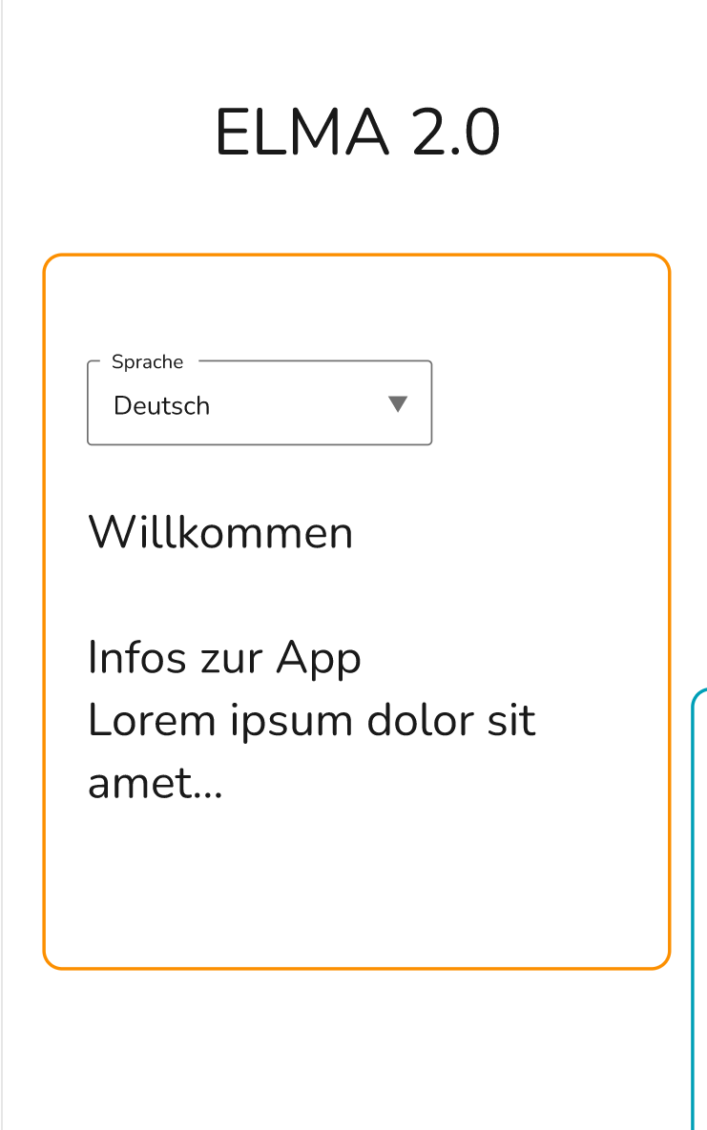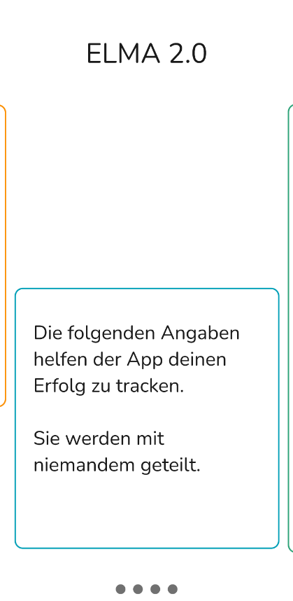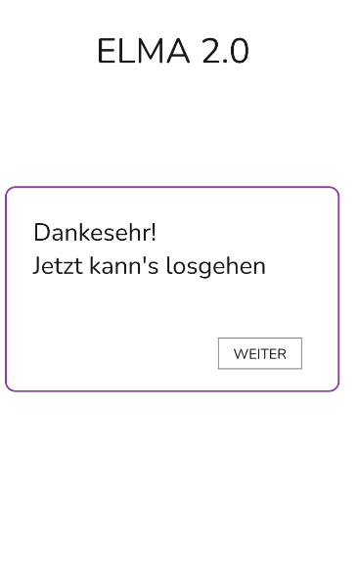

## 10. 2 Activation page

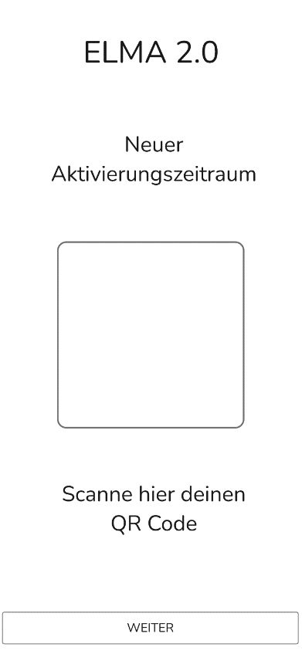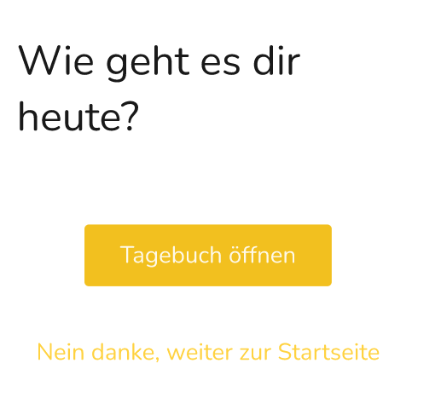

## 10.3 Homepage

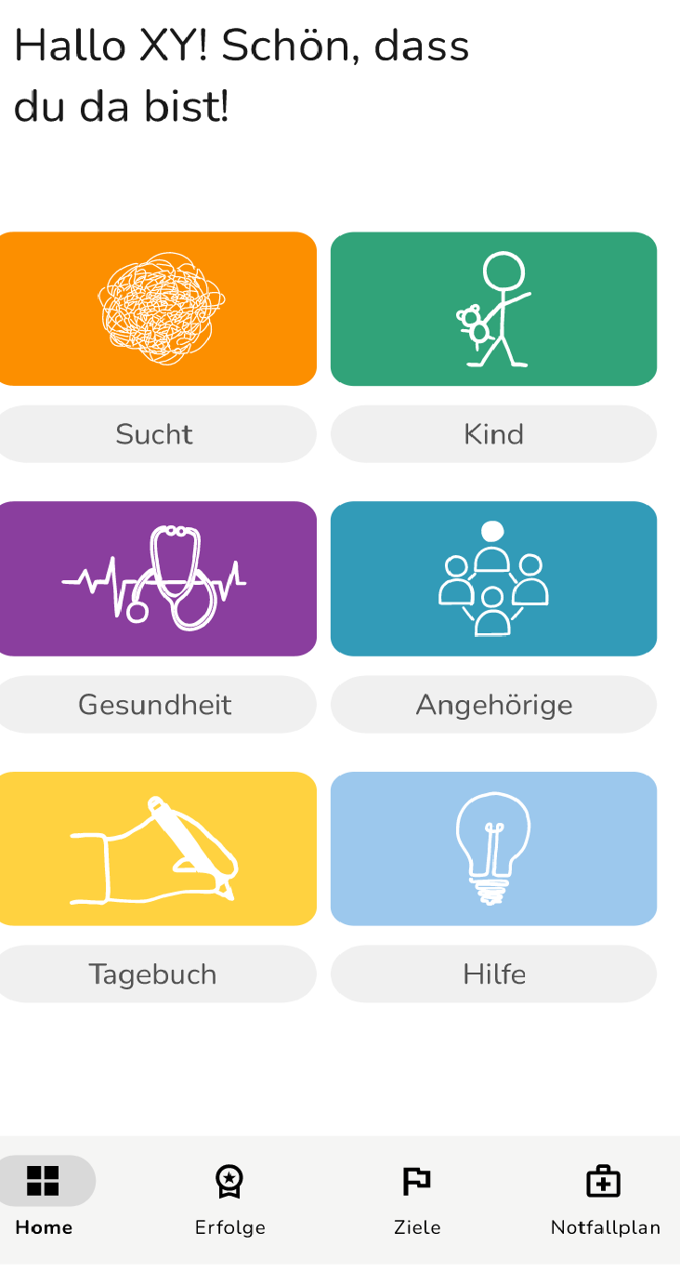

## 10.4 Profile

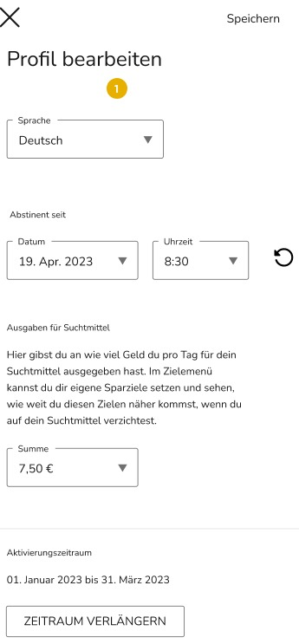

## 10.5 Basic needs of children - Get active

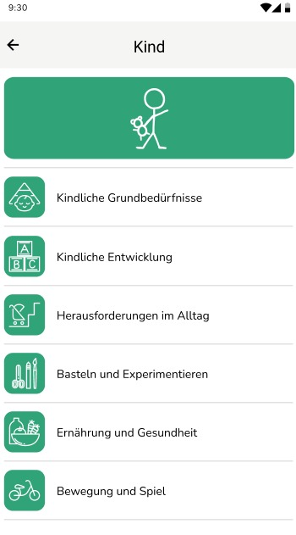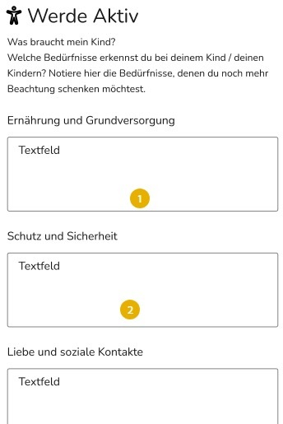

## 10.6 Diary

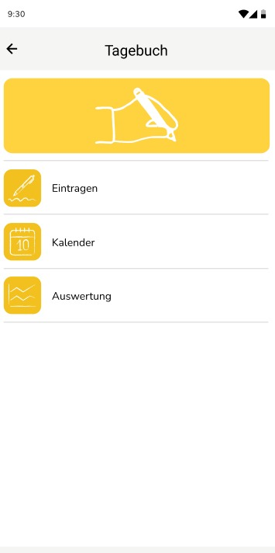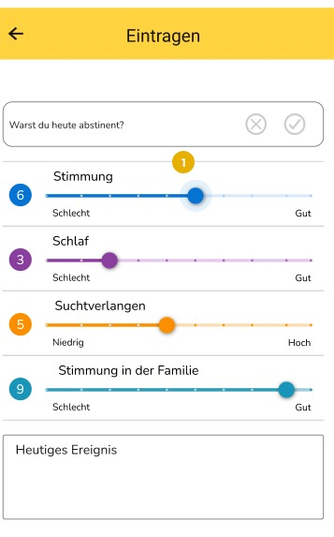

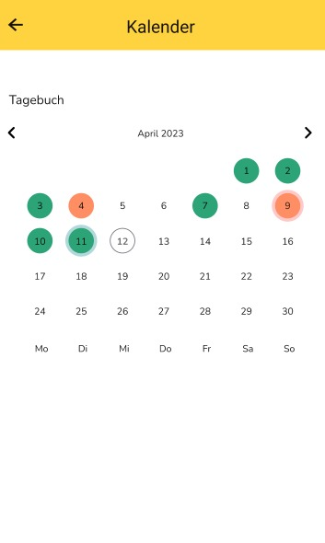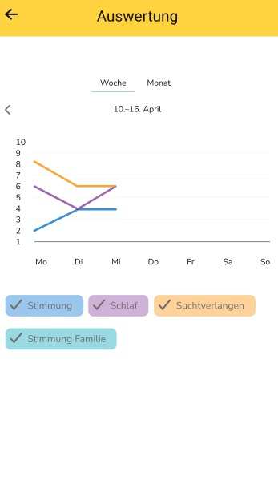

## 10.7 Achievements

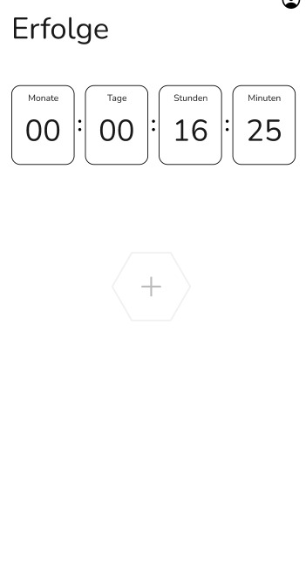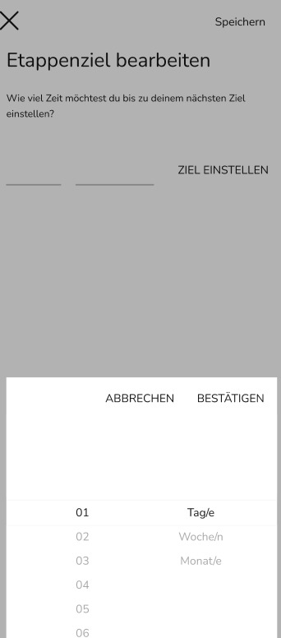

## 10.8 Goals

